Hands-On Lab

Introduction to the   
Modern Requirements Suite4TFS   
& Team Foundation Server 2017

Lab version: 14.0.25123

Last updated: 2/23/2017





Table of Contents

Introduction to the Modern Requirements Suite4TFS & Team Foundation Server 2017 1

Overview 3

Prerequisites 3

About the Fabrikam Fiber Scenario 3

Exercises 3

Installation 5

1. SmartWord4TFS 19

Exercise 1.1: Document Authoring in SmartWord4TFS 19

Exercise 1.2: Instant Document Reporting with SmartWord4TFS using a Template 30

Exercise 1.3: Document Reporting using queries 34

Appendix A: Designing a SmartWord4TFS Template using Wizard 38

2. Traceability Management with inteGREAT4TFS 46

Exercise 2.1: Accessing inteGREAT4TFS and Creating an Intersection Matrix 46

Exercise 2.2: Adding/deleting relationships in Intersection Matrix 58

Exercise 2.3: Editing Work Items 64

Exercise 2.4: Creating a Horizontal Matrix 66

Exercise 2.5: Export to Excel 71

3. Baseline Management with inteGREAT4TFS 73

Exercise 3.1: Accessing inteGREAT4TFS and creating a baseline 73

Exercise 3.2: Generating Baseline Report 83

Exercise 3.3: Comparing Baselines 85

Exercise 3.4: Copying baselines 90

4. Review Management with inteGREAT4TFS 95

Exercise 4.1: Creating a Review Request 95

Exercise 4.2: Responding to the Review Requests 104

## Overview

* 1. The Modern Requirements Suite4TFS provides a collaborative platform based on ‘a single source of truth’, while automating each phase of your requirements lifecycle. The user interface is Microsoft Office or, SmartOffice4TFS, ensuring that you, and your new recruits, can start enjoying the benefits quickly. You can also use the browser based interface, inteGREAT4TFS. Microsoft’s industry leading TFS / VSTS is the requirements database, with optional extensions supporting your end to end ALM process. Whether you deploy it on premises or in the Azure cloud, it provides the security, scalability and workflow management clients’ demand; while supporting Agile, Waterfall or Hybrid methodologies.
  2. In this lab, you will learn about scrum management using the Modern Requirements Suite4TFS modules and augmented by Team Foundation Server 2017 and how these tools can help you to quickly track work across your entire team.

## Prerequisites

* 1. In order to complete this lab, you will need SmartWord4TFS, inteGREAT4TFS and a Visual Studio 2017 virtual machine provided by Microsoft. For more information about the Modern Requirements Suite4TFS products, please visit [this URL](http://www.modernrequirements.com/). The information about acquiring and using the Visual Studio 2017 virtual machine is available [here](http://aka.ms/VS15ALMVM).
  2. **Important note**:
  3. This lab requires you to use the default state of the virtual machine, before any modifications are made to work items or source in TFS. If you followed the “Working With…” instructions, you should have a snapshot/checkpoint of the virtual machine before working with it for the first time. Apply the snapshots/checkpoints before starting this lab.

## About the Fabrikam Fiber Scenario

* 1. This set of hands-on-labs uses a fictional company, Fabrikam Fiber, as a backdrop to the scenarios you are learning about. Fabrikam Fiber provides cable television and related services to the United States. They are growing rapidly and have embraced Windows Azure to scale their customer-facing web site directly to end-users to allow them to self-service tickets and track technicians. They also use an on-premises ASP.NET MVC application for their customer service representatives to administer customer orders.

In this set of hands-on labs, you will take part in a number of scenarios that involve the development and testing team at Fabrikam Fiber. The team, which consists of 8-10 people, has decided to use Visual Studio application lifecycle management tools in conjunction with SmartExcel4TFS.

# Exercises

This hands-on lab includes the following exercises:

1. SmartWord4TFS
   1. Document Authoring in SmartWord4TFS
   2. Instant Document Reporting with SmartWord4TFS using a Template
   3. Document Reporting using queries
   4. Estimated time to complete Exercise 1: 60 **minutes**.
2. Traceability Management with inteGREAT4TFS
   1. Accessing inteGREAT4TFS and creating an Intersection Matrix
   2. Adding/deleting relationships in Intersection Matrix
   3. Editing Work Items
   4. Creating a Horizontal Matrix
   5. Export to Excel
   6. Estimated time to complete Exercise 2: 60 **minutes**.
3. Baseline Management with inteGREAT4TFS
   1. Accessing inteGREAT4TFS and creating a baseline
   2. Generating Baseline Report
   3. Comparing baselines
   4. Copying baselines
   5. Estimated time to complete Exercise 3: 60 **minutes**.
4. Review Management with inteGREAT4TFS
   1. Creating a Review Request
   2. Responding to the Review Requests
   3. Estimated time to complete Exercise 2: 30 **minutes**.
   4. Estimated time to complete this entire lab: 210 **minutes**.

## Installation

The following prerequisites are required to successfully install SmartOffice4TFS products:

* Microsoft VM environment for Visual Studio 2017
* Internet should be working within the VM Refer to “Working with the Visual Studio 2013 Update 3 ALM Virtual Machine.docx”

**Installing SmartWord4TFS**

This Installation Guide elaborates the installation of SmartWord4TFS using Web Installer:

**Installation Guidelines**

1. Go to the following link : <http://www.modernrequirements.com/application-lifecycle-management-virtual-machine/>
2. Please submit the online registration form and click submit to download button (refer to the screen shot).

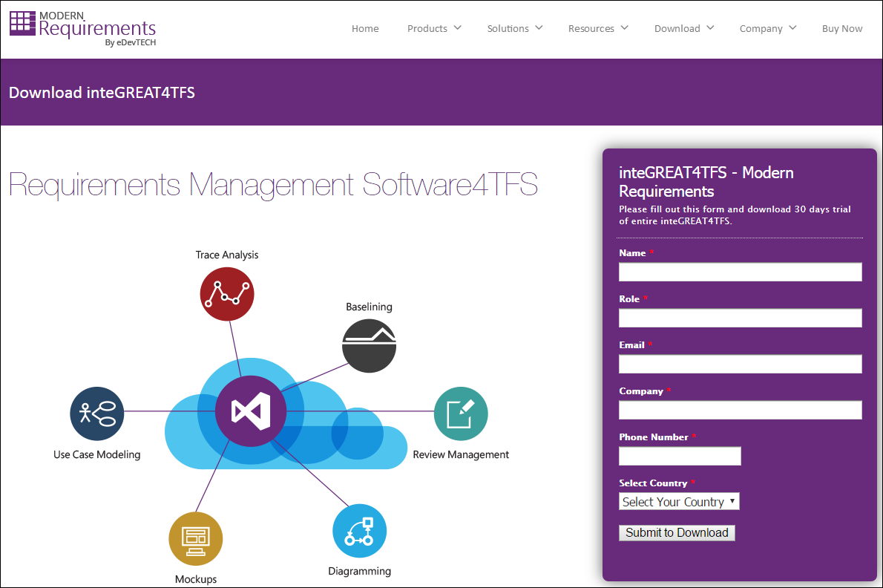

**Figure 1**

Registration form for downloading SmartWord

1. You will be navigated to the download page.
2. Click on **SmartWord4TFS web installer (590 KB)**.

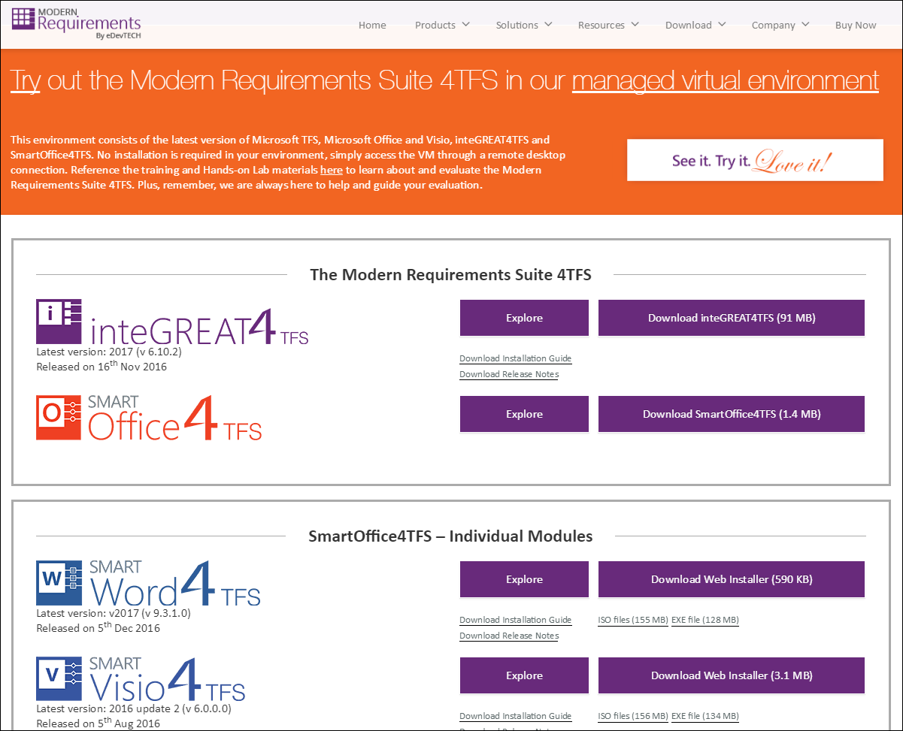

**Figure 2**

SmartWord4TFS download page

* For system requirements inteGREAT4TFS installation guide & SmartWord4TFS installation guide

1. Once the installer is downloaded click the installer to start the installation process.

**Installation Process**

* The following screenshot shows the online installer.

1. Run the **SmartWord4TFS.exe** file

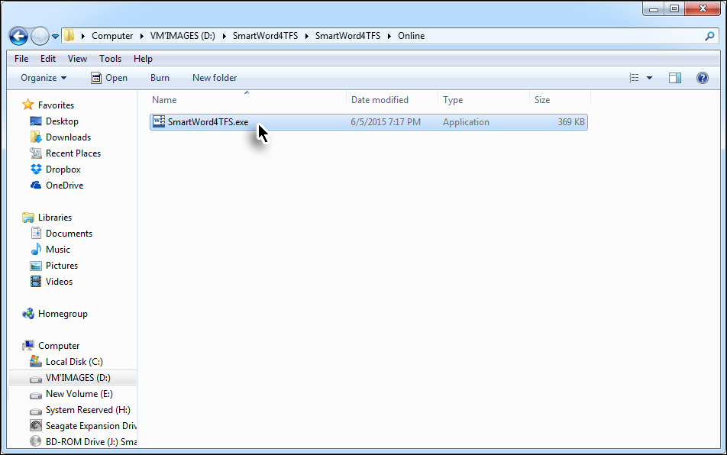

**Figure 3**

Invoking the SmartWord4TFS Installer

1. Click the **Next** Button to start the installation process.

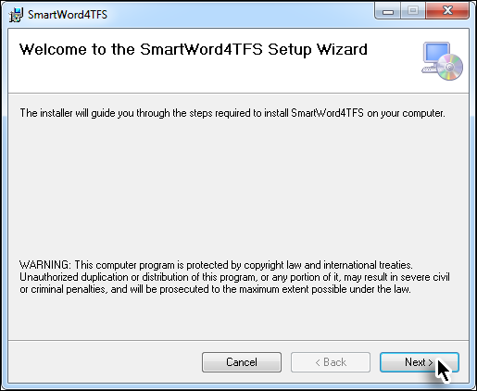

**Figure 4**

Installation Step 1

1. Read the License Agreement, select **I Agree** option and click the **Next** Button.

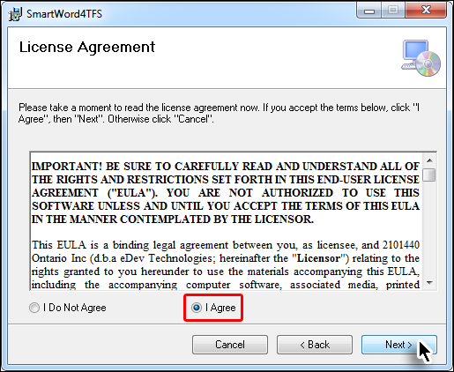

**Figure 5**

Installation Step 2

1. Set the desired installation location and the relevant user accounts then click the **Next** Button.

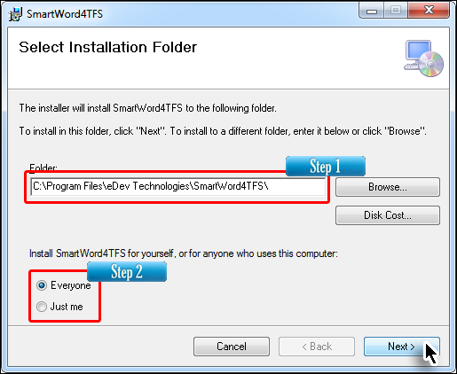

**Figure 6**

Installation Step 3

1. Select the desired mode (**Author** or **Reviewer**) and click the **Next** Button.

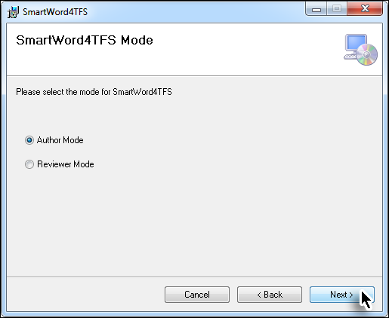

**Figure 7**

Installation Step 4

1. Select if the templates are to be installed and then click **Next** Button.

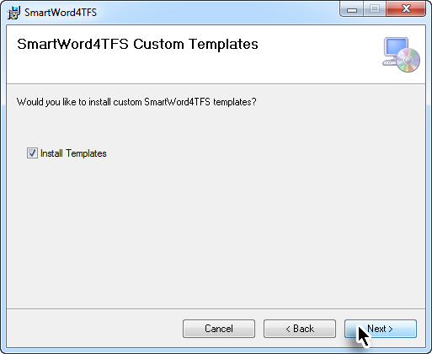

**Figure 8**

Installation Step 5

1. Click the **Next** Button to begin copying the files onto your system.

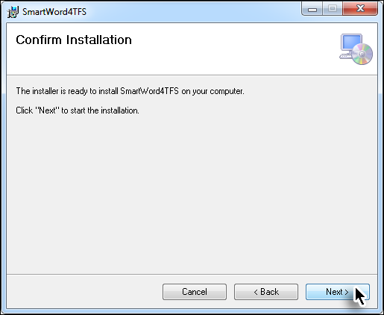

**Figure 9**

Installation Step 6

* The actual installation starts based on selections done in previous steps.

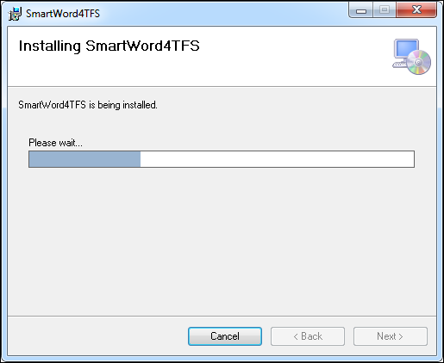

**Figure 10**

Installation Step 7

1. Click on the **Close** Button to complete the installation process.

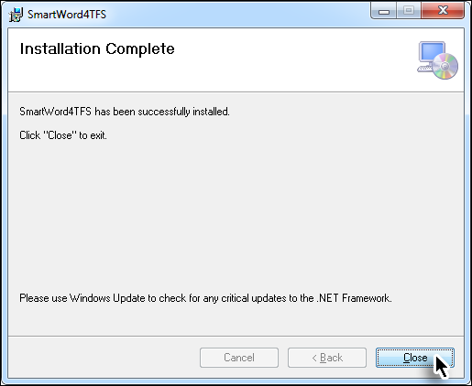

**Figure 11**

Installation Step 8

* The **SmartWord4TFS** Tab (or **SmartWord4TFS Review** Tab if you chose to install the **Reviewer Mode**) can now be accessed in Microsoft Word.



**Figure 12**

SmartWord4TFS Tab in MS-Word

* The downloaded version provides 30 days trial period for users to evaluate the application.

1. Click the **About** option in Ribbon Bar 🡪 **Activate** Button (in the **About** window)

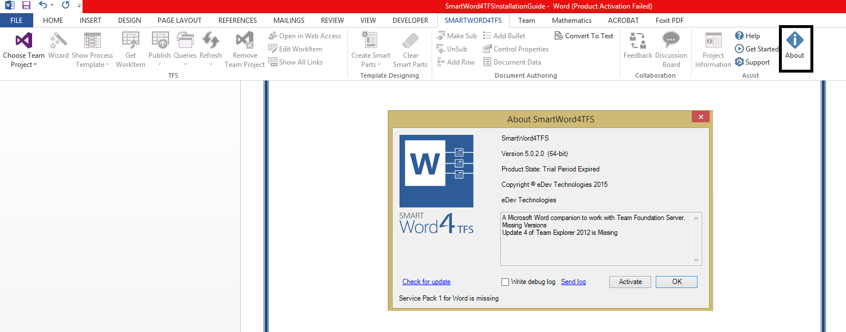

**Figure 13**

About Text Box showing the Activate Button

* After submitting the online registration form you will receive the License key for 6 month duration to the provided email address. This software key is provided for non-production use only.

1. Enter the provided Activation key and click **Activate** button.

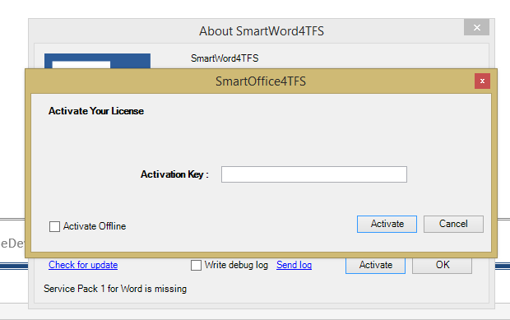

**Figure 14**

Activation Window

* Entering a valid Activation Key activates SmartWord4TFS.

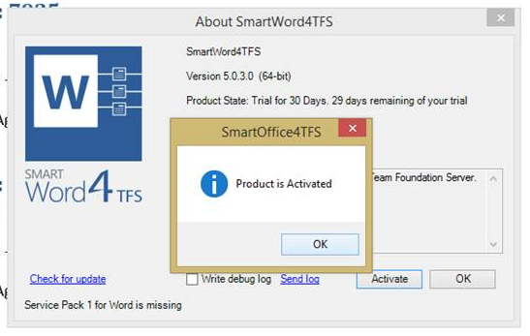

**Figure 15**

Successful activation message

**Installation Process for inteGREAT4TFS**

* Download the inteGREAT4TFS installer using the same process described above for SmartWord4TFS.

1. Double click the **inteGREAT4TFS 2017.exe** file.

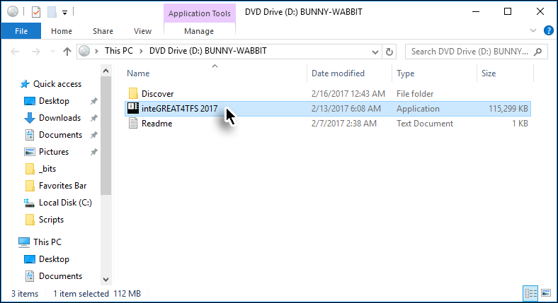

**Figure 16**

Invoking the inteGREAT4TFS Installer

1. Select the terms and conditions agreement check box and then click the **Next** Button.

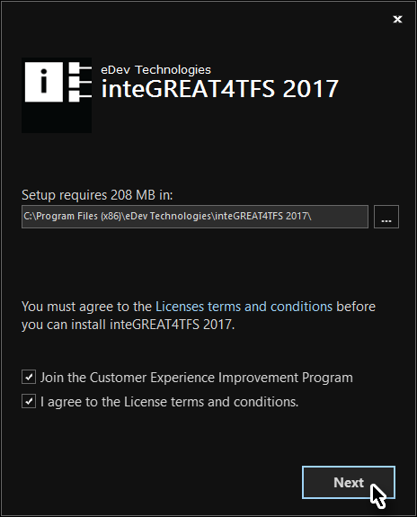

**Figure 17**

Step 1 inteGREAT4TFS installation

1. Enter the following Windows credentials:

Username = **Administrator**  
Password = **P2ssw0rd**

and then click the **Next** Button.

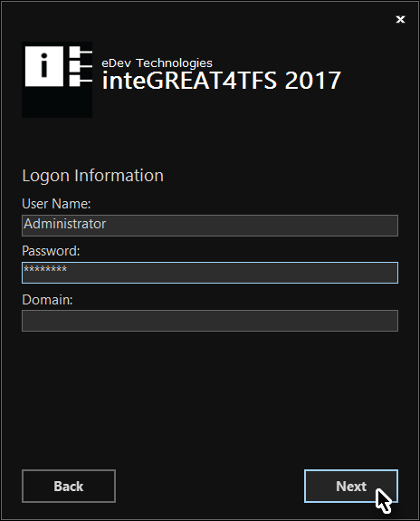

**Figure 18**

Step 2 of installation

* Application would be installed, even if incorrect windows credentials entered during the installation, however user will not be able to login into the application.

1. Configure **Redis Installation** options* and click the **Install** Button.

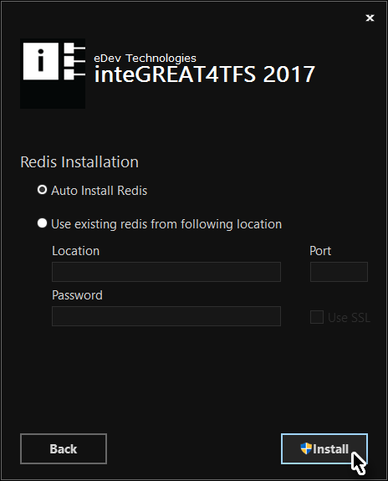

**Figure 19**

Step 3 of installation

* **Auto Install Redis** option is the recommended option if Redis is not already installed on the VM.

* The relevant files are installed.

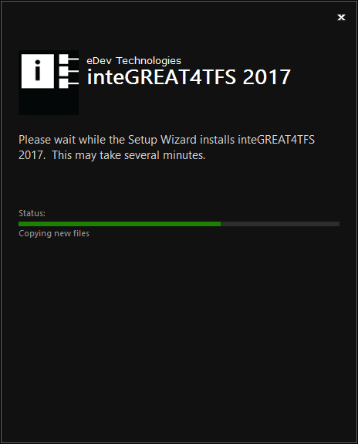

**Figure 20**

Step 4 of installation

1. Complete the Installation of **inteGREAT4TFS** by clicking the **Finish** Button.

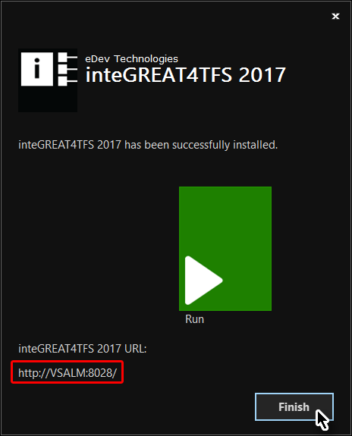

**Figure 21**

Final step of installation

* Please note down the Service URL (highlighted in the above images). This would be helpful later on.
* This completes the installation process of inteGREAT4TFS. After installing all SmartOffice4TFS and inteGREAT4TFS modules we can proceed to the following exercises.

1. SmartWord4TFS

### Exercise 1.1: Document Authoring in SmartWord4TFS

The templates created in SmartWord4TFS can be distributed to all stakeholders enabling them to create and manage Work Items from MS-Word in relevant Team Projects on the Team Foundation Server.

In this exercise we would use an MS-Word template* to create new Work Items and publish these Work Items on the Fabrikam Fiber Team Project.

* Refer to **Appendix A** at the end of this file for instructions to create the template being used in this exercise.

1. Open the Word Template (created using **Appendix A**) by double-clicking on it.

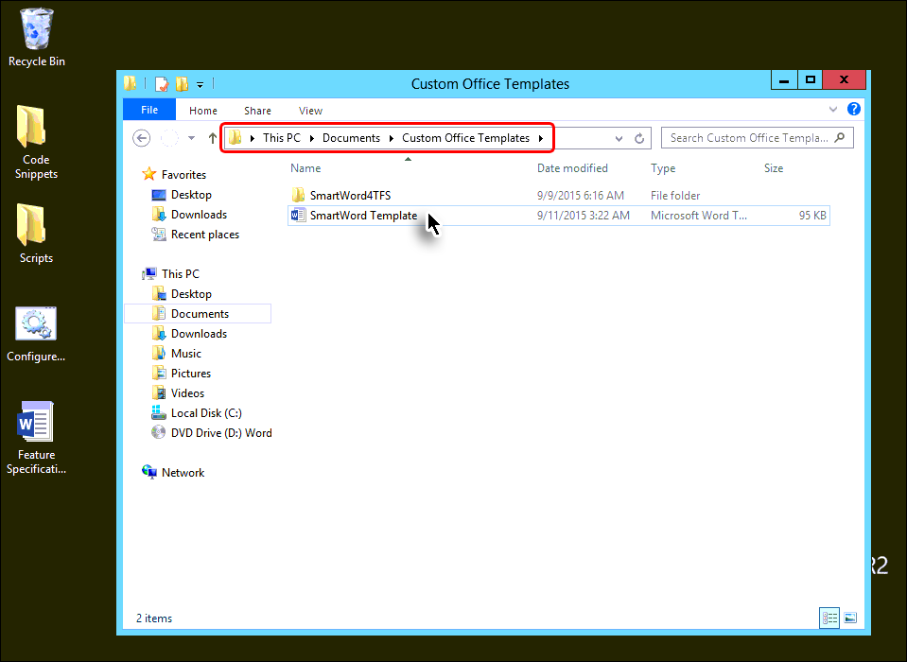

* + 1. Figure 17

Opening the template

* The template with empty Work Item Smart Parts is opened. The controls that are used to set Individual properties of any work item are called **Smart Parts**. These are used to create new Work Items so these can be published on the Team Project.

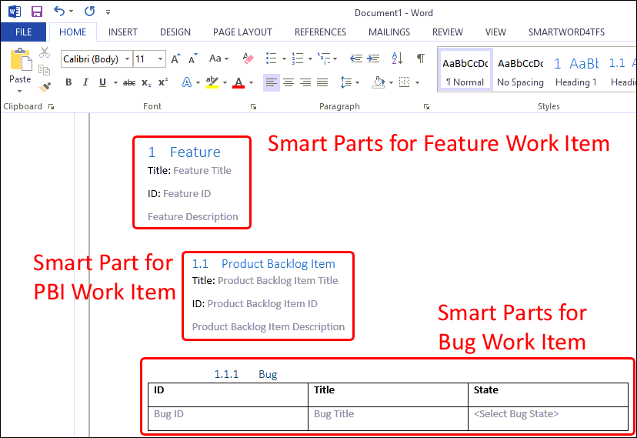

**Figure 18**

Word Template with empty Work Item Smart Parts

1. Click the SMARTWORD4TFS Tab.

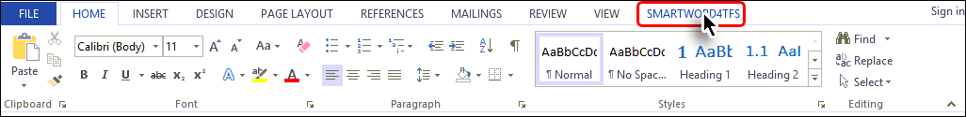

* + 1. Figure 19

Accessing the SmartWord4TFS Tab

1. Click the **Choose Team Project** option.

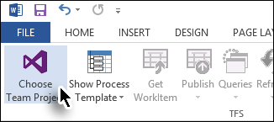

* + 1. Figure 20

Initiating the connection process

1. Choose **FabrikamFibreCollection** 🡪 **Fabrikam Fiber** (Team Project) 🡪 click the **Connect** Button.

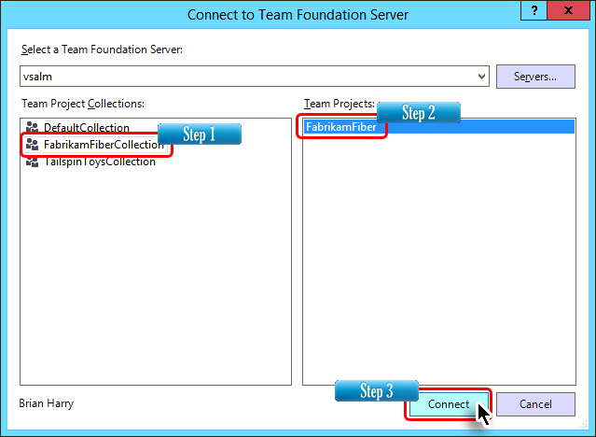

* + 1. Figure 21

Selecting the Team Project

1. Click inside the **Feature Title** smart part.

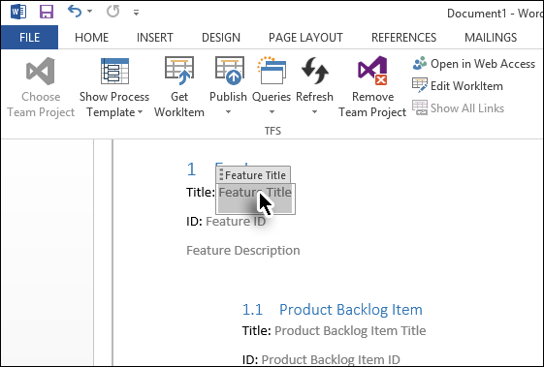

* + 1. Figure 22

Entering values in Document

1. Enter a suitable name for the Feature Work Item.

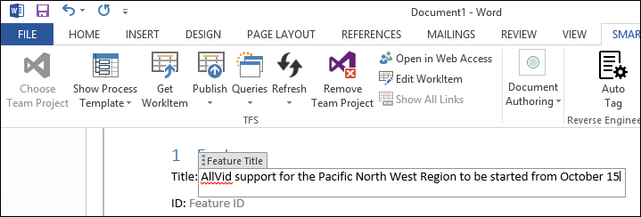

* + 1. Figure 23

Entering values in Document

* The ID of a Work Item is automatically given by the connected Team Project, when that Work Item is first published on the Team Project therefore we would leave that field for the time being as it would be populated after the Work Item is published.

1. Similarly, enter values in all Smart Parts of the Work Items.

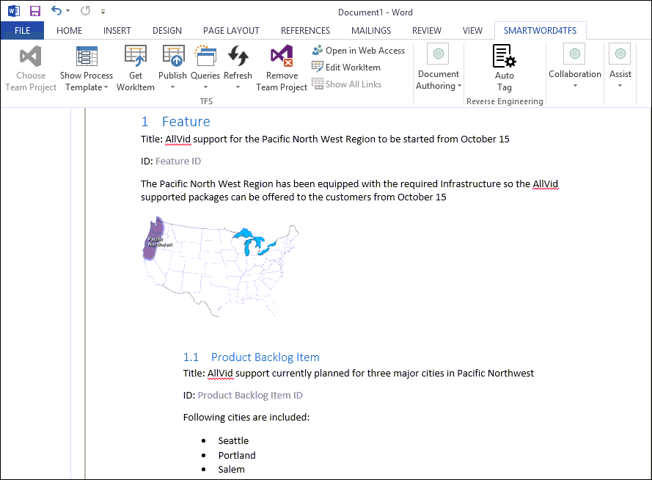

* + 1. Figure 24

Entering values in all smart parts

1. Click the **Publish** option in the Ribbon Bar.

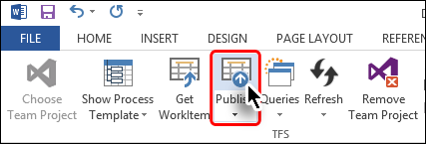

* + 1. Figure 25

Publishing the Work Item on the Team Project

* There is a subtle difference between **Publish** (shown here) and **Publish Selected** (accessed through drop down).
* **Publish** option publishes all Work Items while **Publish Selected** only publishes the Work Item whose smart parts are selected by the user.

1. Provide any comments (if desired) and click the **Yes** Button.

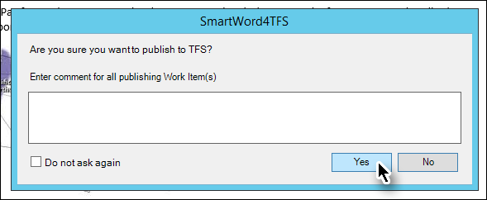

* + 1. Figure 26

Confirming Publish

* The Work Items are published on the Fabrikam Fiber Team Project.

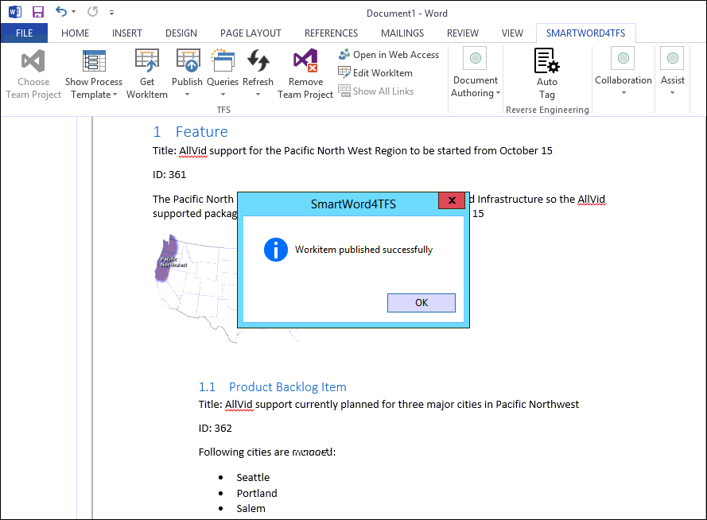

* + 1. Figure 27

Document after publishing Work Items

1. Now add values in the Smart Part of the Bug Work Item.

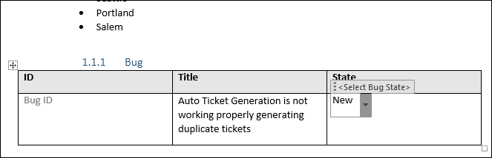

* + 1. Figure 28

Entering values in Bug’s Smart Part

* At this moment we have run out of Smart Parts. So far we have been using the Smart Parts that came with the template. What if we need to add more Work Items? To do this we need to **Insert Smart Part.**

1. Click **Document Authoring** 🡪 **Insert Smart Part** 🡪 **Product Backlog Item** 🡪 **Bug**

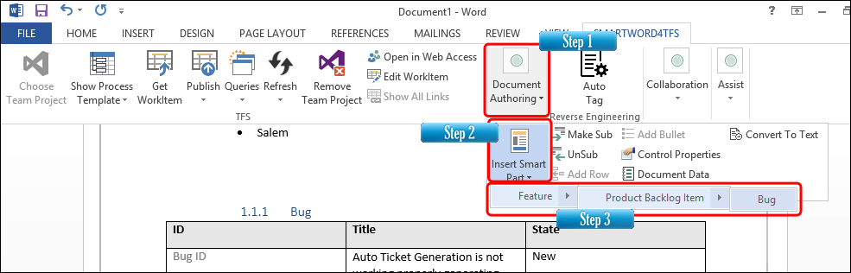

* + 1. Figure 29

Inserting Smart Parts for creating a new Bug Work Item

1. Add values to the new Bug Smart Parts.

* We now have two Bug Work Items ready to be published. However, in order to elaborate the Publish Selected functionality, we would publish only one. This is done by first selecting the Smart Parts of the desired Bug Work Item.
* To select the Smart Parts of the desired Work Item, a user may select all of the relevant Smart Parts, partially selecting any one Smart Part, or even just placing the cursor in any of the Smart Parts of that Work Item would also suffice.

1. Place the cursor inside any of the Smart Parts of the Bug that we created in Step 6.

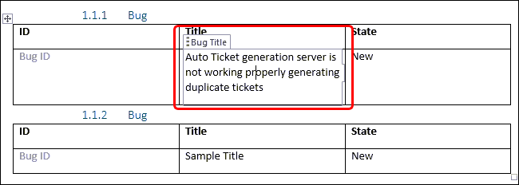

* + 1. Figure 30

Selecting the desired Smart Part before publishing

1. Click **Publish** 🡪 **Publish Selected** option in the Ribbon Bar.

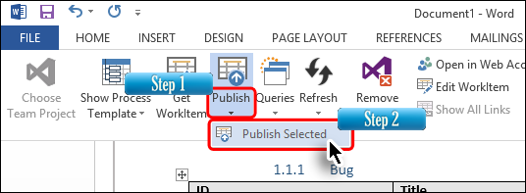

* + 1. Figure 31

Publishing the desired Bug out of the two

* The desired Bug is published on the Fabrikam Fiber Team Project.

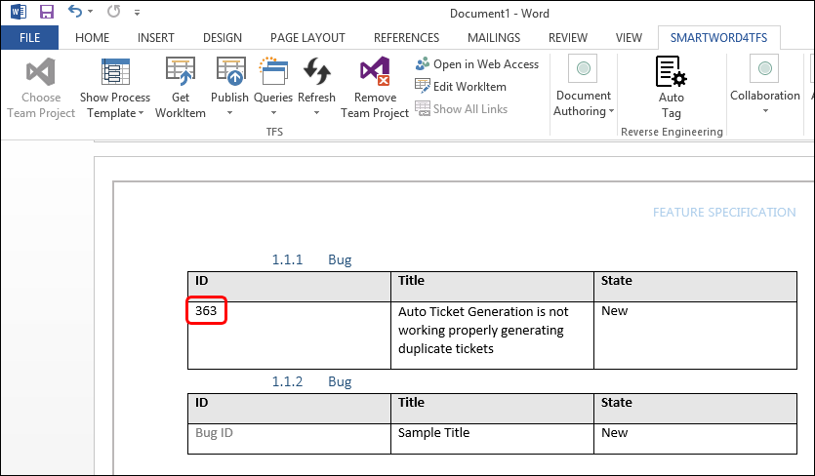

* + 1. Figure 32

Document after publishing the Bug Work Item

* The last step is to check the published Work Items on the Team Project.

1. Run **Visual Studio 2017**.
2. Run the **All Bugs** query.

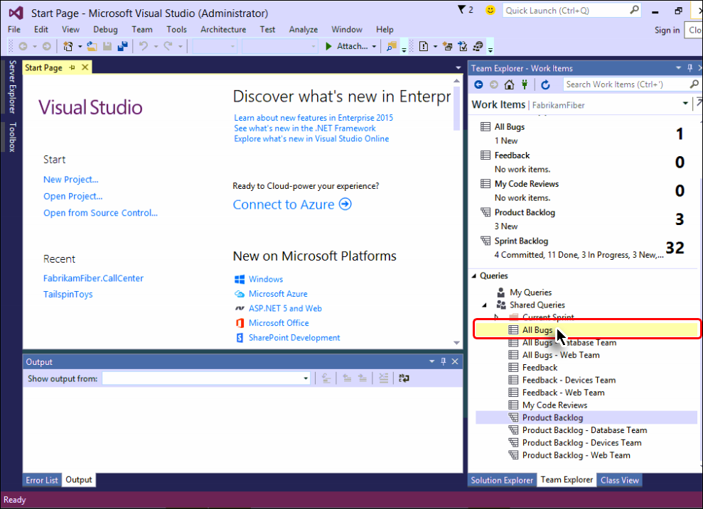

* + 1. Figure 33

Running the All Bugs query in Visual Studio

* The Bug Work Item can be seen in the Team Project. Similarly we can run relevant queries, to check other Work Items on the Team Project that we published before the Bug Work Item.

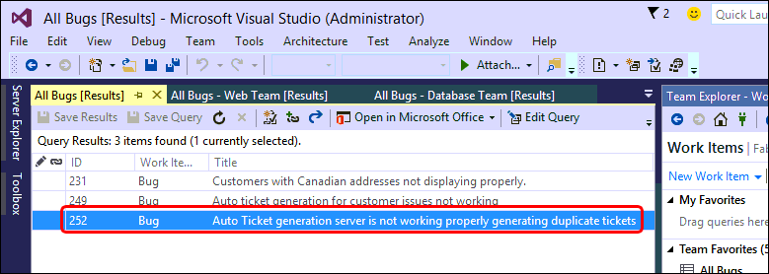

* + 1. Figure 34

Published Bug Work Item as seen in Visual Studio 2017

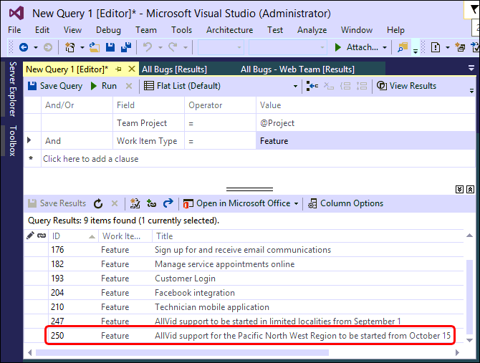

* + 1. Figure 35

Published Feature Work Item as seen in Visual Studio 2017

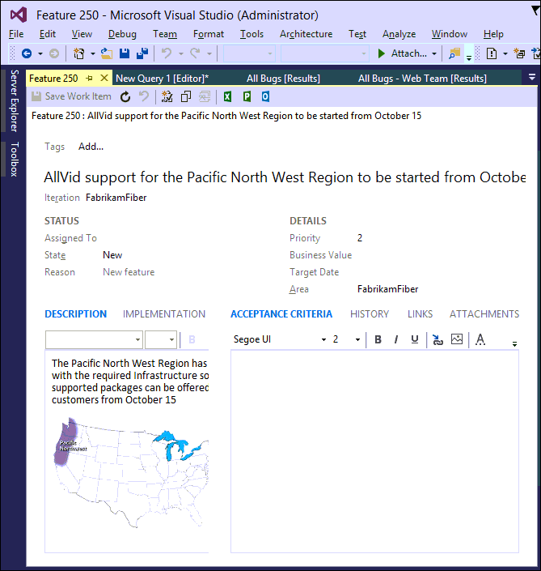

**Figure 36**

Details of the published Feature Work Item

* The image depicts SmartWord4TFS’ support of Rich Content Data to be published on the Team Project.
* This brings us to the end of this exercise.

### Exercise 1.2: Instant Document Reporting with SmartWord4TFS using a Template

In this exercise you will learn how to create an instant report about Project PBIs using a SmartWord4TFS template. You will also learn how to update Work Items on the Team Project while staying in Word.

* .

1. Log in as **Julia Ilyiana** (VSALM\Julia). All user passwords are **P2ssw0rd**.
2. Start MS-Word and open the **Product Backlog Item List.dotx** from the **Documents** folder.

* All necessary work to populate the file with Product Backlog Items is already in place in the document. The report is generated by a single click, as shown in the document.

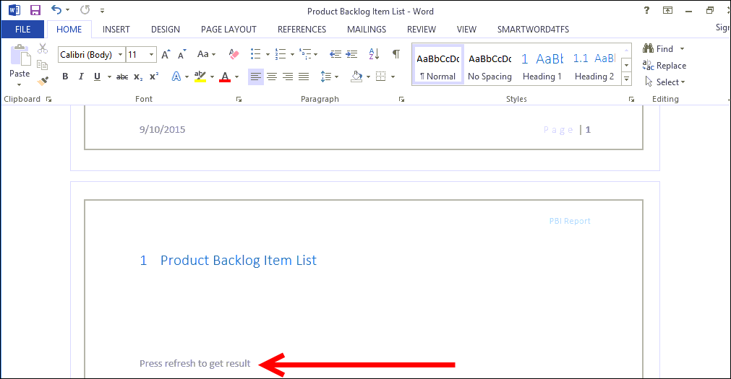

* + 1. Figure 37

Document in original state

1. Click the SMARTWORD4TFS Tab.



* + 1. Figure 38

Clicking the SmartWord4TFS Tab

1. Click the **Refresh** option.

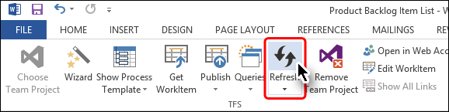

* + 1. Figure 39

Refreshing the document to generate instant report

* Refreshing the document populates it by fetching all the PBIs from Fabrikam Fiber Team Project. Similar documents can be created to generate reports about desired Work Items. For more details contact [Modern Requirements](http://www.modernrequirements.com/contact/).

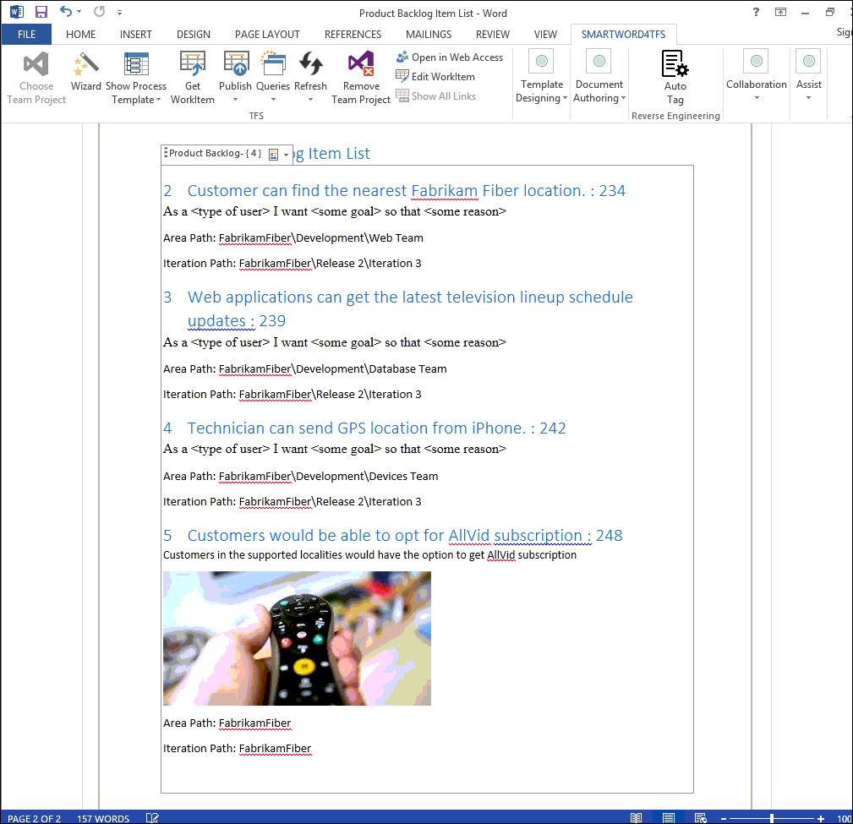

* + 1. Figure 40

Document displaying all PBIs after refresh option has been selected

* Now we will update one of our PBIs and publish the updated Work Item on the Team Project.

1. Click inside the last Product Backlog Item and update its description as shown in the image.

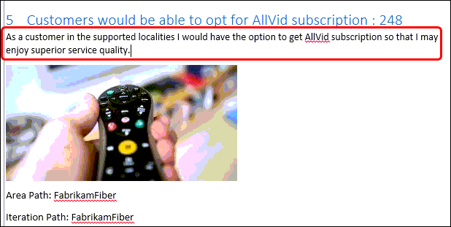

* + 1. Figure 41

Updating a PBI

1. Click the **Publish 🡪 Publish Selected** option.

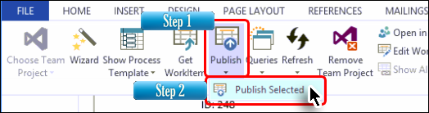

* + 1. Figure 42

Publishing updated PBI on Team Project

* This option publishes the updates on our Fabrikam Fiber Team Project.

1. Run **Visual Studio 2017**.
2. Run the relevant query and open the PBI that we updated in Word.

* We can see that our PBI has been updated on the Team Project.

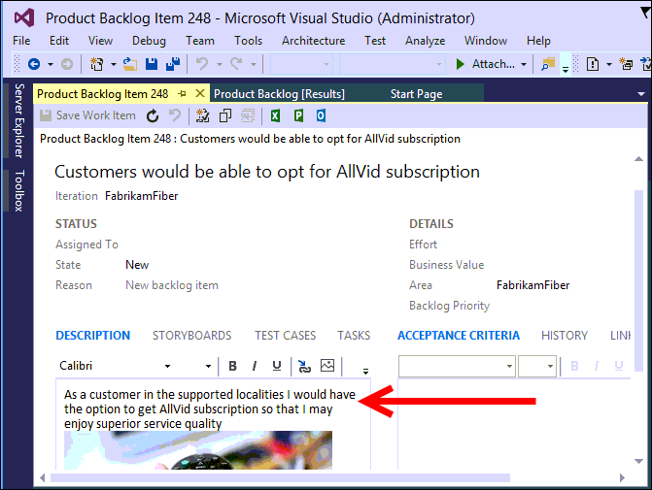

* + 1. Figure 43

Updated PBI in Team Project

* This brings us to the end of this exercise.

### Exercise 1.3: Document Reporting using queries

In the previous exercise we used a ready-made template to create an instant report. This exercise explores the query option to create a report with more freedom in what to include in the report

1. Log in as **Julia Ilyiana** (VSALM\Julia). All user passwords are **P2ssw0rd**.
2. Start MS-Word and create a new document.
3. Format the document as required including header/footer, title page, document control information etc.

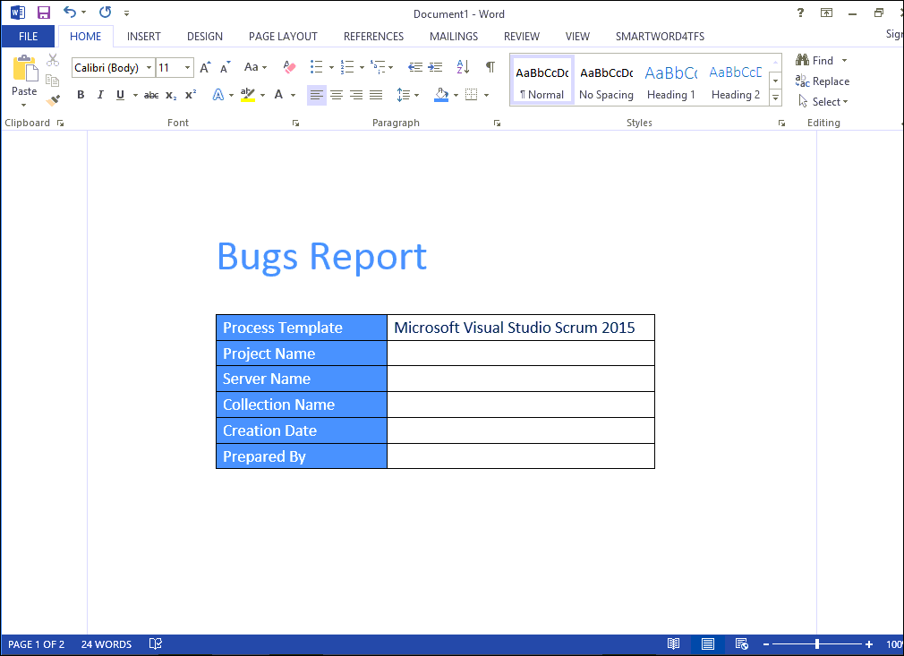

* + 1. Figure 44

Formatting the document

1. Click the **SMARTWORD4TFS** Tab.



* + 1. Figure 45

Accessing the SmartWord4TFS Tab

1. Click the **Choose Team Project** 🡪 **Team Project** option.

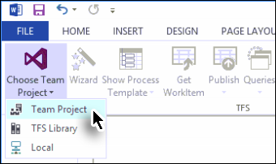

* + 1. Figure 46

Initiating the connection process

1. Choose **FabrikamFibreCollection** 🡪 **Fabrikam Fiber** (Team Project) 🡪 click the **Connect** Button.



* + 1. Figure 47

Selecting the Team Project

1. Click the **Queries** option and select the desired query from the drop-down menu.

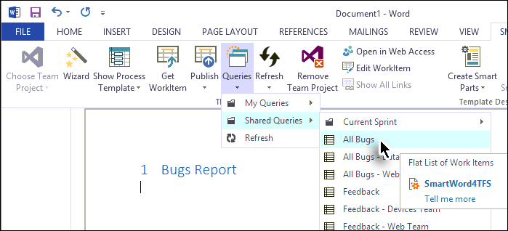

**Figure 48**

Selecting the desired query

* The Query Dialogue Box appears with the following information and options:
* **Query Name** (i.e. the selected Query)
* **Query Type** (i.e. Is the query a simple list or a tree)
* Work Item Count
* **Without smart content** Check Box: If selected the query would be inserted as tables with plane text. The values in the table would not be smart content.
* **Insert at cursor position** Check Box: If selected the query would be inserted at the current cursor location, otherwise at the end of the document.
* **Insert query block only** Check Box: If selected; an empty query control is added in the document without any Work Items (refer to the image at the bottom of the page). The query control can be refreshed later, to be filled with the relevant Work Items. The Template we used in Exercise 2 was created by using this option.

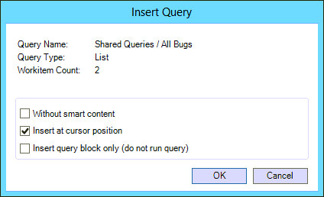

**Figure 49**

Query options

1. Enable only the middle check box while leaving the other two checkboxes un-selected. Then click the **OK** Button.

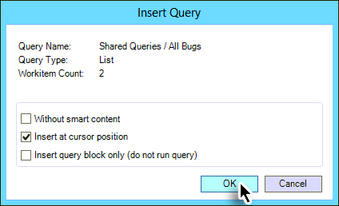

**Figure 50**

Finalizing Query options

* The result of the query is added in the document.

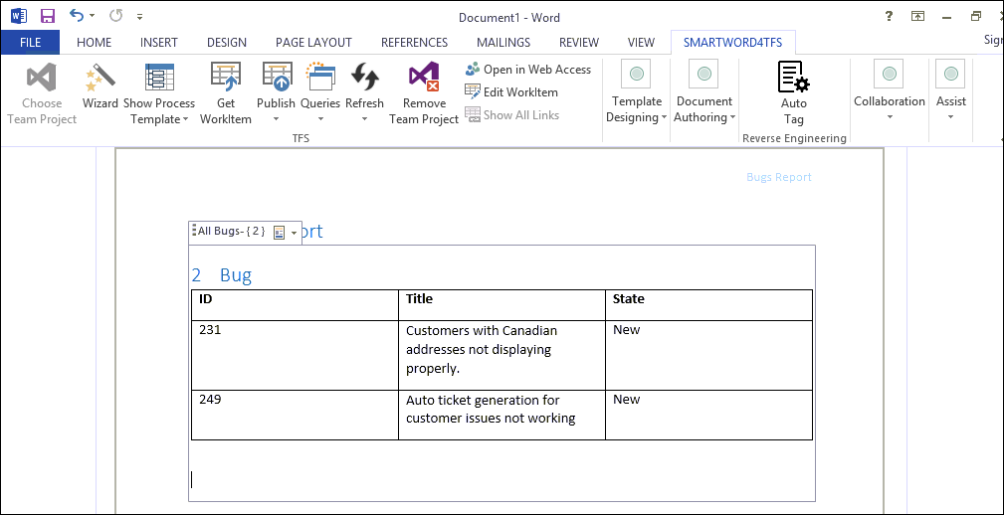

**Figure 51**

Document after running the query

* This brings us to the end of the exercise.

### Appendix A: Designing a SmartWord4TFS Template using Wizard

In this appendix you will learn how to create a new SmartWord4TFS template from scratch using the Wizard.

* The Wizard makes the template designing process quite easy even for novice users. Another way is to create the template using individual controls but that is for advanced users and hence not discussed in this exercise.

1. Log in as **Julia Ilyiana** (VSALM\Julia). All user passwords are **P2ssw0rd**.
2. Start MS-Word and create a new document.
3. Format the document as required including header/footer, title page, document control information etc.

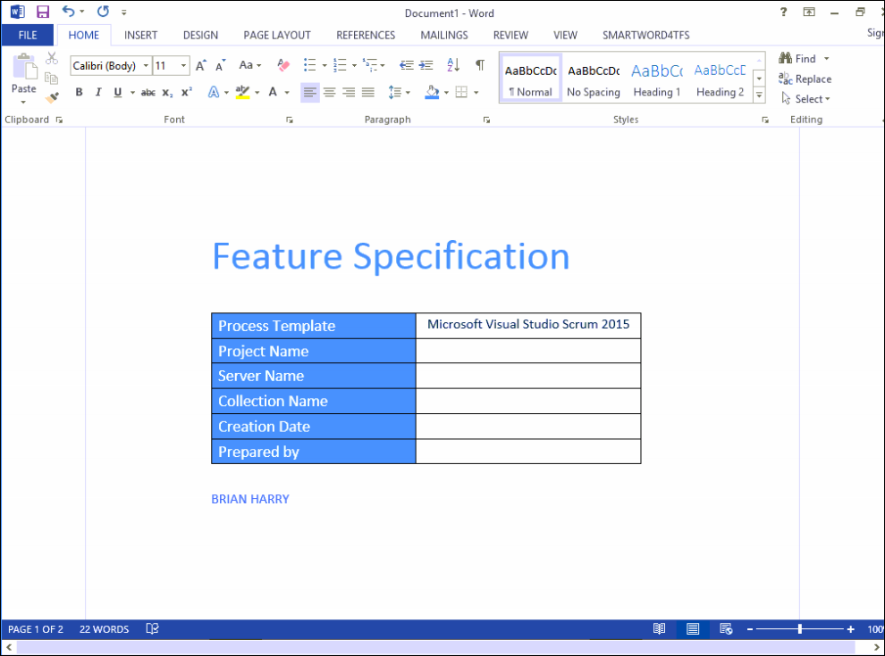

* + 1. Figure 109

Formatting the document

1. Click the **SMARTWORD4TFS** Tab.



* + 1. Figure 110

Accessing the SmartWord4TFS Tab

1. Click the **Choose Team Project** 🡪 **Team Project** option.



* + 1. Figure 111

Initiating the connection process

1. Choose **FabrikamFibreCollection** 🡪 **Fabrikam Fiber** (Team Project) 🡪 click the **Connect** Button.



* + 1. Figure 112

Selecting the Team Project

1. Click the **Wizard** option.

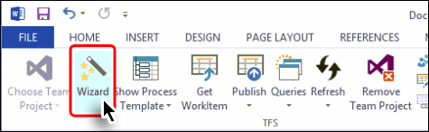

* + 1. Figure 113

Initiating the Wizard

1. Click the **Create section** Button (at top left of the window).

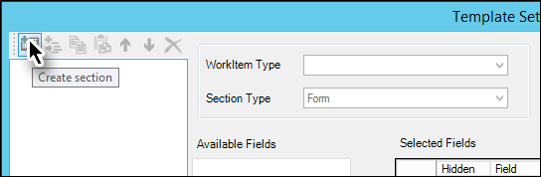

* + 1. Figure 114

Section creation in Wizard (Step1)

1. Enter a suitable name for the section.

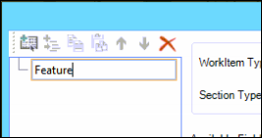

* + 1. Figure 115

Section creation in Wizard (Step2)

* This section would serve as a root node and would be used to show a certain type of Work Item. We could have sub-section(s) to display the Work Items in the desired hierarchy.

1. Select the desired Work Item Type

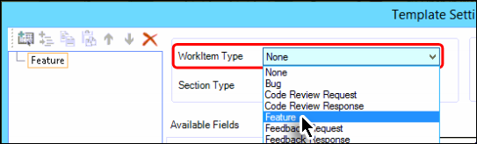

* + 1. Figure 116

Selecting the relevant Work Item

1. Select the desired Section Type, to determine how the Work Item would be displayed in the template/document.

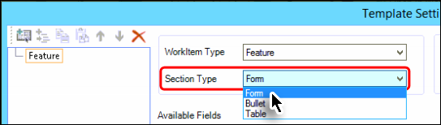

* + 1. Figure 117

Selecting the relevant section type

1. Select the desired field from the available list and include it in the Smart Part using the arrow button.

* Users can select multiple fields by holding down the **Ctrl** key and clicking all the desired fields from the list.

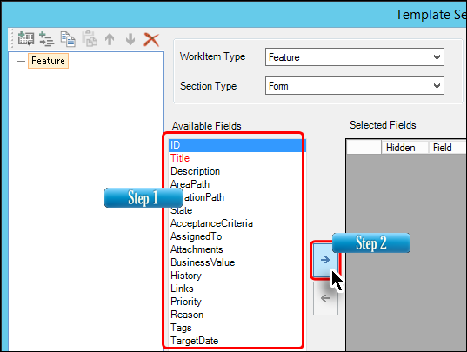

* + 1. Figure 118

Selecting the desired fields

1. Arrange the selected fields in the desired order (using arrow buttons) and customize them (if desired).

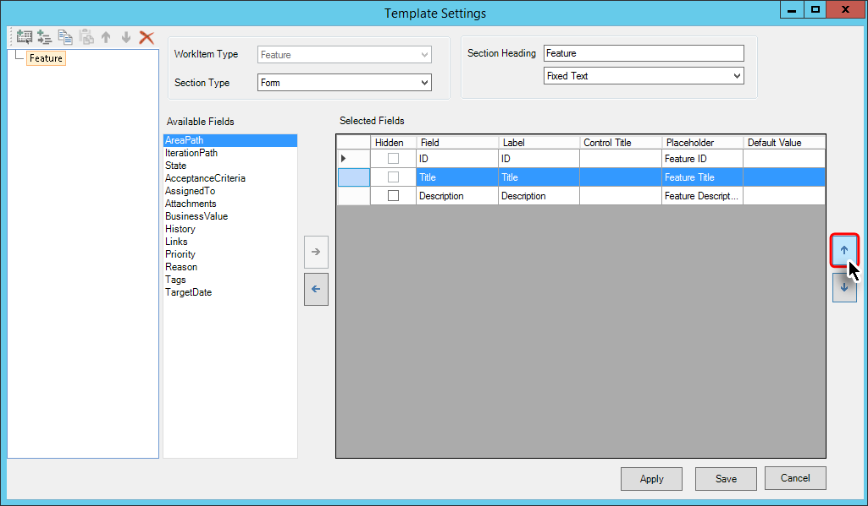

* + 1. Figure 119

Arranging the fields

* Users can make a selected field to be hidden, using the relevant checkbox. For the Hidden fields, users have to provide corresponding default values. Hidden field do not appear in the Word document, however their default values are published automatically on TFS (along with other normal fields) when users perform a **Publish** command.

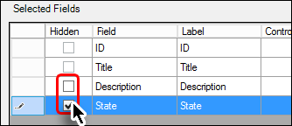

**Figure 120**

Hidden field check boxes

* Note that not every field can be a hidden field. For such fields, the relevant check boxes remain disabled as evident from the **ID** and **Title** check boxes shown in the above image.

1. Give a heading for the selected fields as you want it to appear in the template/document. The Heading could be given using Section Heading or selected from the drop down control.

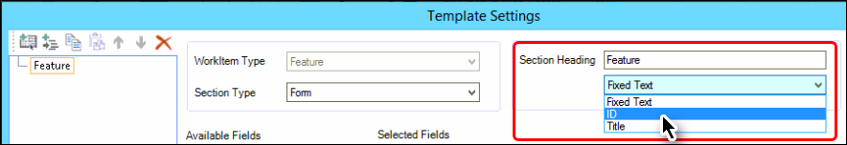

* + 1. Figure 121

Heading the fields

* This completes the formatting of a Work Item node that started with step 9.

1. Now click the **Create Sub Section** Button (at top left of the window).

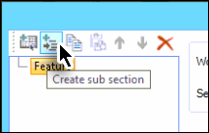

* + 1. Figure 122

Sub Section creation in Wizard (Step1)

1. Enter a suitable name (e.g. PBI) for the sub section, as we did for the section in step 9.
2. Repeat Step 9 to 14 with the sub section, this time formatting the node for **Product Backlog Item**.

* During the course of creating this guide we have designed the template with the following section hierarchy:

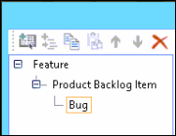

**Figure 123**

* Section Hierarchy used in this example

1. Click the **Apply** Button to save the changes and complete the template creation process.

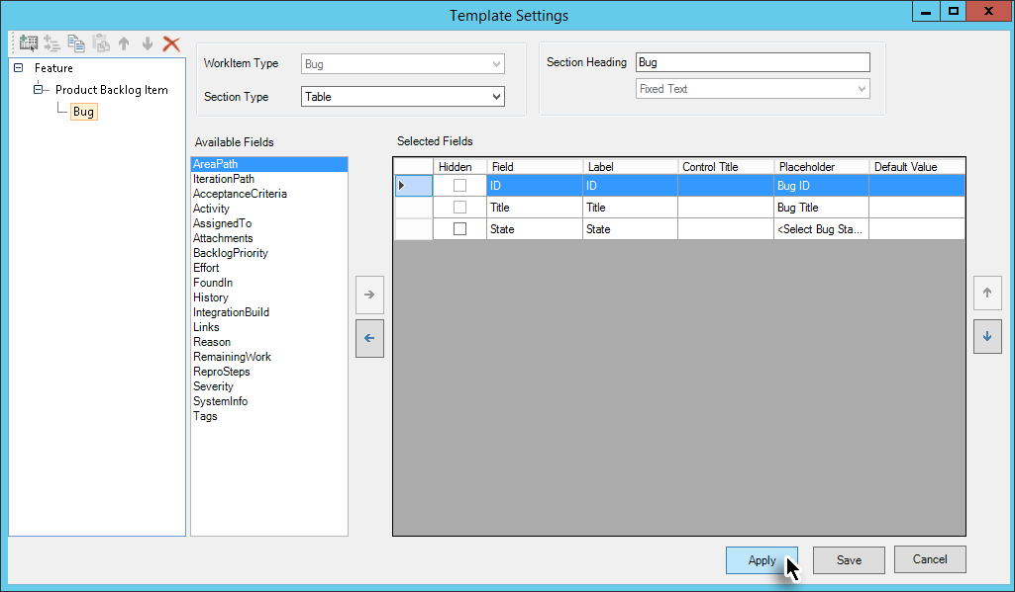

* + 1. Figure 124

Finishing the wizard

* This completes the template creation process. The hierarchy of nodes becomes visible in the document as shown in the following image. Now we only need to save the template.

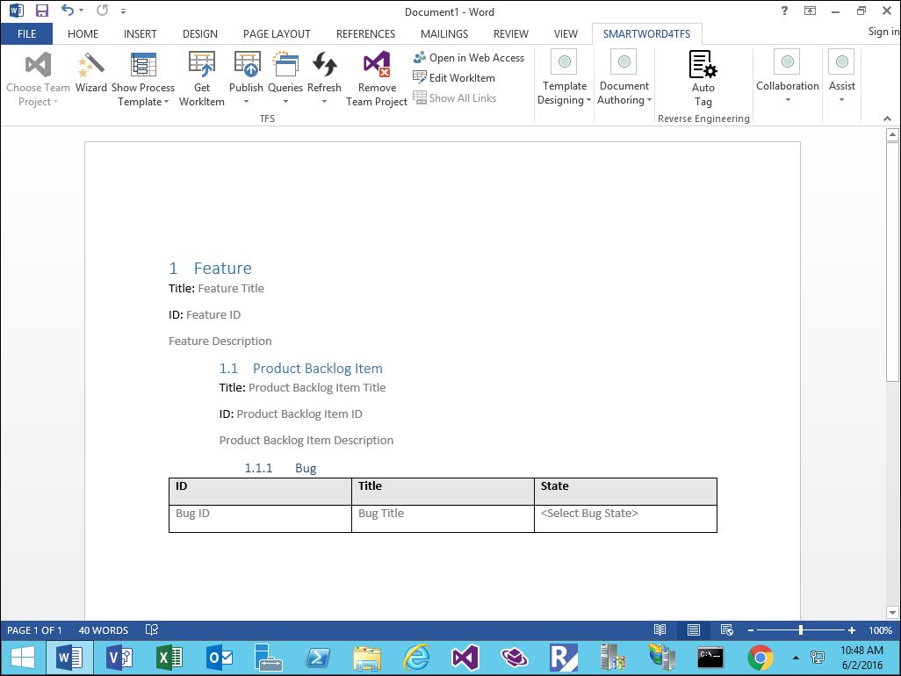

**Figure 125**

Document after completing the wizard

1. Save the document as a template (with .dotx extension) to complete the template creation process.

## 2. Traceability Management with inteGREAT4TFS

### Exercise 2.1: Accessing inteGREAT4TFS and Creating an Intersection Matrix

In this exercise you will learn how to create an Intersection Matrix using the Trace Analysis module of inteGREAT4TFS.

* inteGREAT4TFS is an online application that complements SmartOffice4TFS in managing Team Projects. inteGREAT4TFS consists of many distinct modules such as: **Trace Analysis**, **SmartOffice Library**, **Simulation, Diagram, Use Case,** **Review** and **Baselining**. In this HOL, we would be using the **Trace Analysis** module only.

1. Log in as **Administrator** with the password **P2ssw0rd**.
2. Start Internet Explorer.
3. Access the following URL: **VSALM:8028**

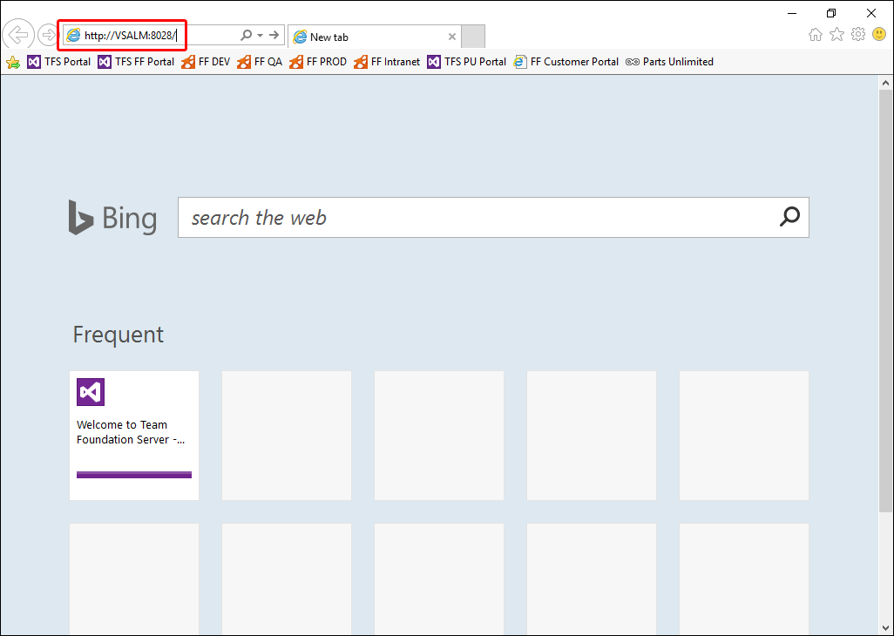

* + 1. Figure 1

Accessing inteGREAT4TFS Tab

* The Login Page for inteGREAT4TFS is displayed in the browser.

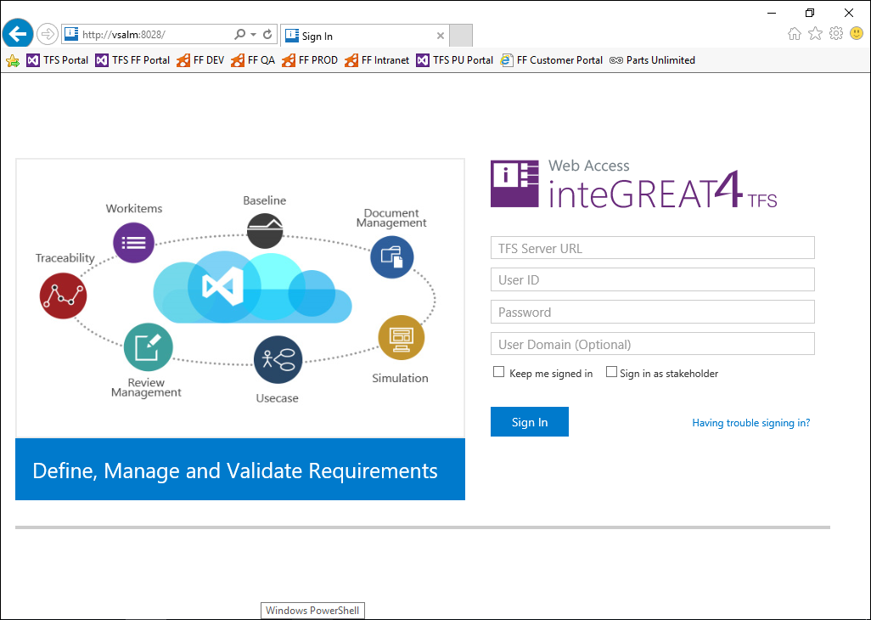

**Figure 2**

Login Page for inteGREAT4TFS

* Following login details are to be used:
* TFS Server URL: [**http://VSALM:8080/tfs**](http://VSALM:8080/tfs)
* User ID: **Administrator**  
  Password: **P2ssw0rd**

1. Enter the login details and click the **Sign In** Button.

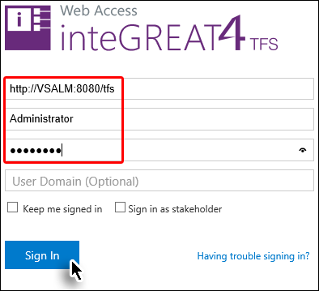

* + 1. Figure 3

Signing in using the recommended login details

1. Enter a valid key (if provided) to activate OR use the **Trial** option.

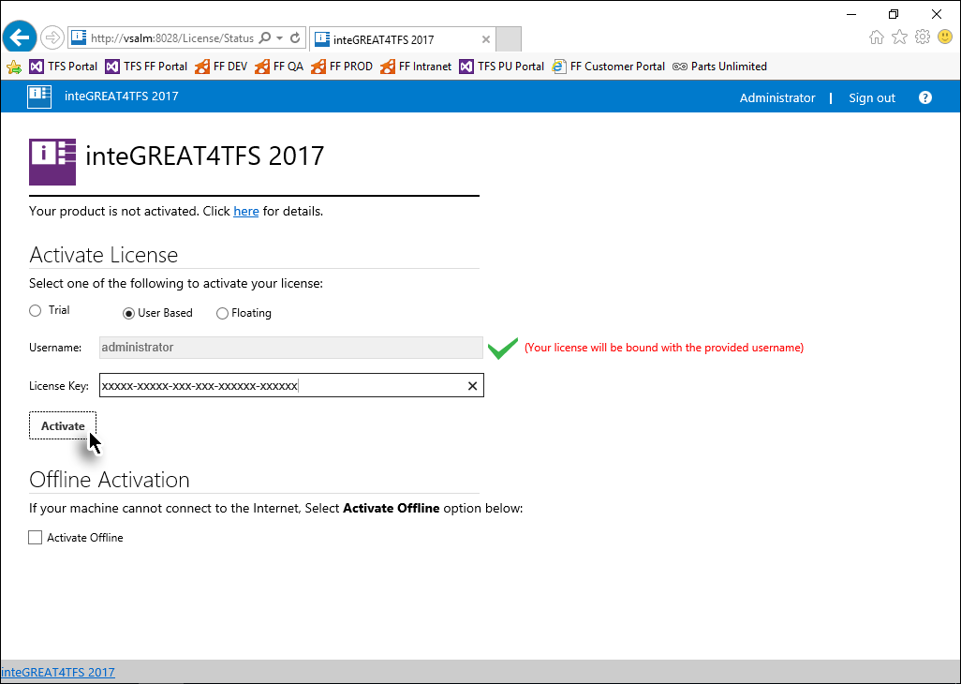

Figure 4

Activating inteGREAT4TFS

* Home page is displayed.

1. Click the **Browse** link.

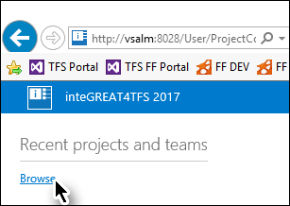

**Figure 5**

Browse link on the home page

1. Expand **FabrikamFibreCollection** node 🡪 select **Fabrikam Fiber** (Team Project) 🡪 click the **Navigate** Button.

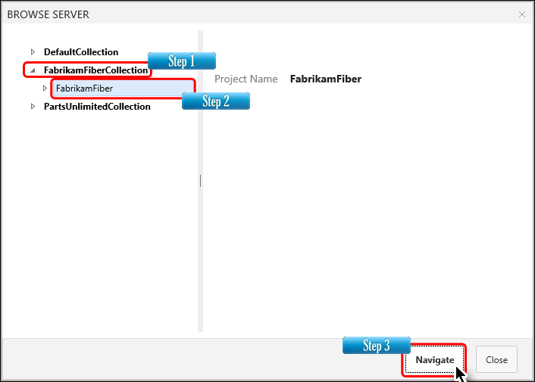

* + 1. Figure 6

Selecting the Team Project

* Upon successful connection, the Dashboard of the selected Team Project (**Fabrikam Fiber**) is displayed.

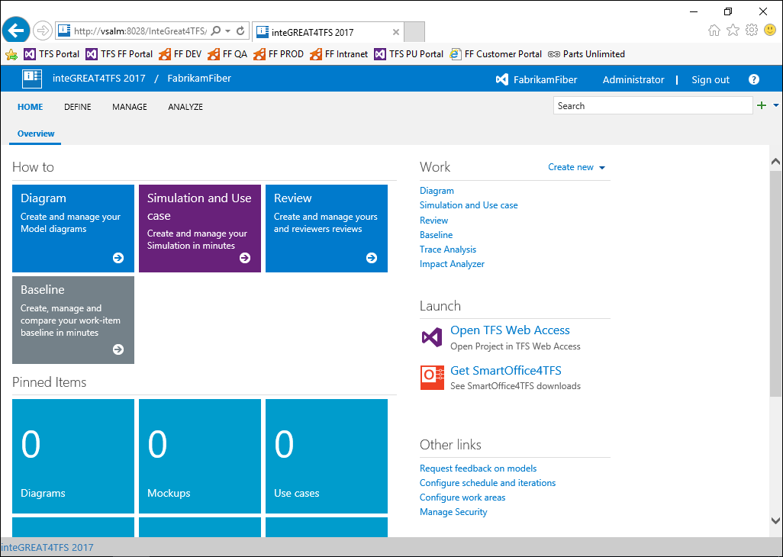

**Figure 7**

Dashboard in inteGREAT4TFS

* **Dashboard** is the place wheretheuser gets useful information about the team project. It also leads the users to the desired module in inteGREAT4TFS. Users can select their desired module in a number of ways. Since we would be using the **Trace Analysis** module in this exercise, we would select it.

1. Select the **Trace Analysis** link from the highlighted links shown in the following image.

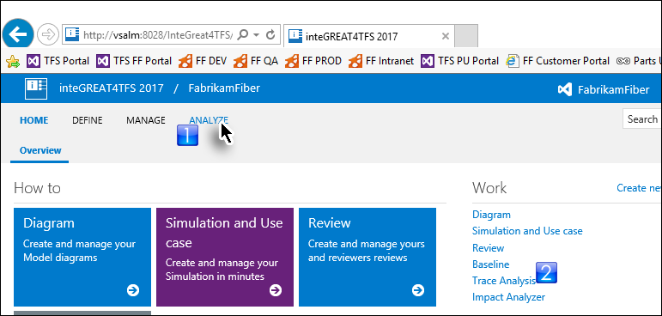

* + 1. Figure 8

Selecting the Trace Analysis module

* The landing page of the Trace Analysis module is displayed. Originally it would be empty since we have not created any traceability as of yet.

1. Click **New** and then **Traceability** options from the drop down.

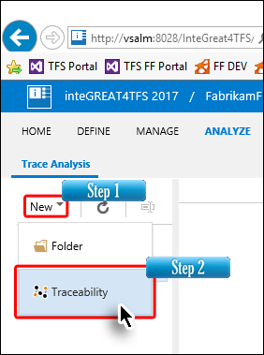

Figure 9

Invoking the traceability creation option

1. Enter a suitable name for the Intersection Matrix and click the **OK** Button.

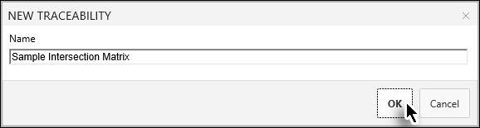

**Figure 10**

Naming the Intersection Matrix

* Clicking the **Next** button takes us to the Editor page where we configure the settings to create the Intersection (and also the Horizontal) Matrix.
* The Intersection Matrix can be created as **Work Item Type** or **Saved-Query Type**. In this lab we will create the matrix as Work Item Type.
* The Work Item Type gives more control to user enabling him to choose the desired Work Item instead of pre-saved queries. In the Saved-Query type, users can only select those Work Items for which a relevant query exists in the selected Team Project.

1. Set the Area and Iteration Path as **Fabrikam Fiber** (if not already selected).

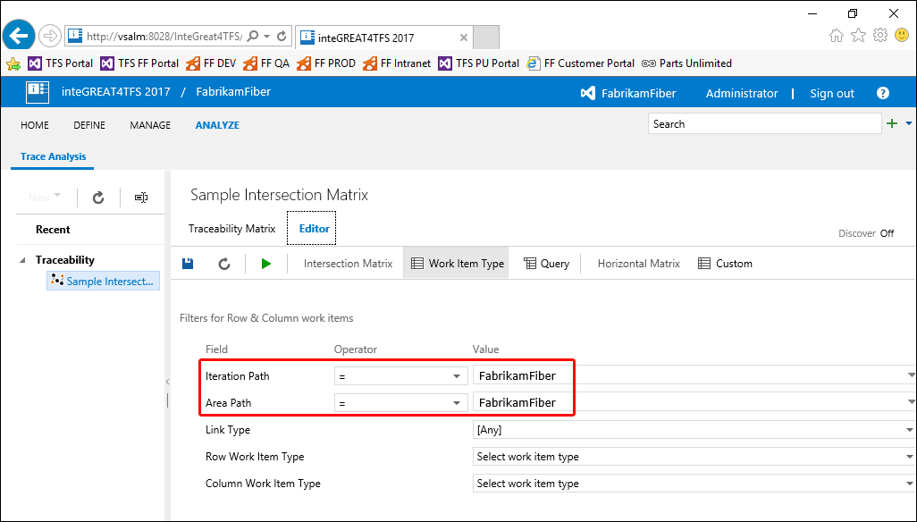

**Figure 11**

Configuring the Area and Iteration Paths for Work Item Type Interaction Matrix

1. Select the desired Link Type.

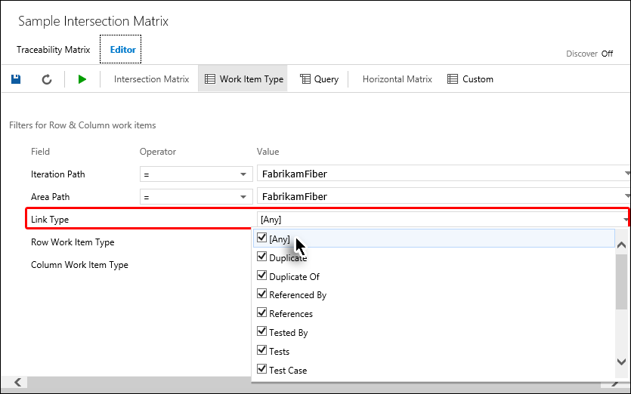

**Figure 12**

Configuring the Link Type

1. Select the desired Row Work Item Type.

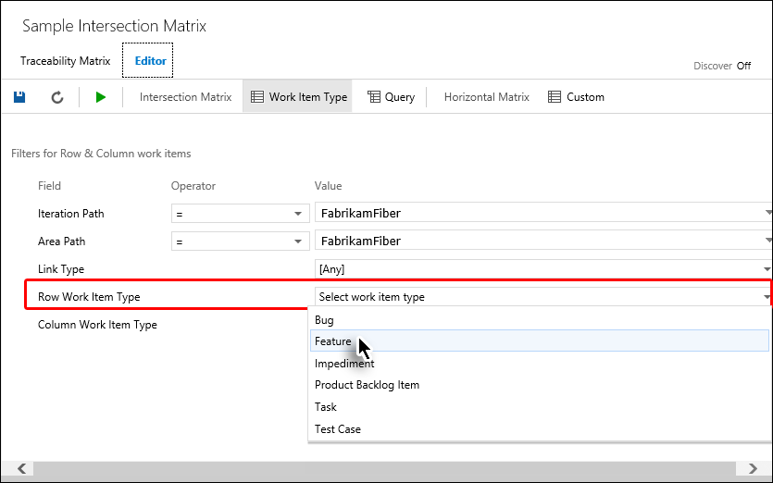

* + 1. Figure 13

Configuring the Row Work Item

1. Similarly, select the desired Column Work Item Type.

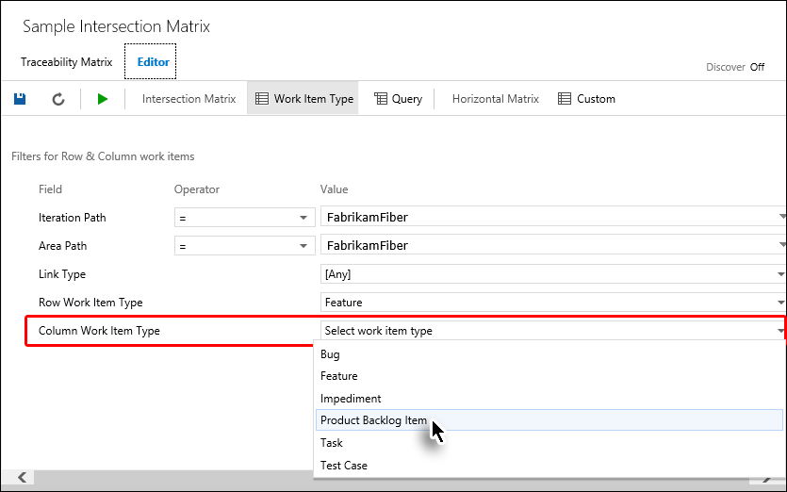

* + 1. Figure 14

Configuring the Column Work Item

1. Now click the **Run Query** option in the Toolbar.

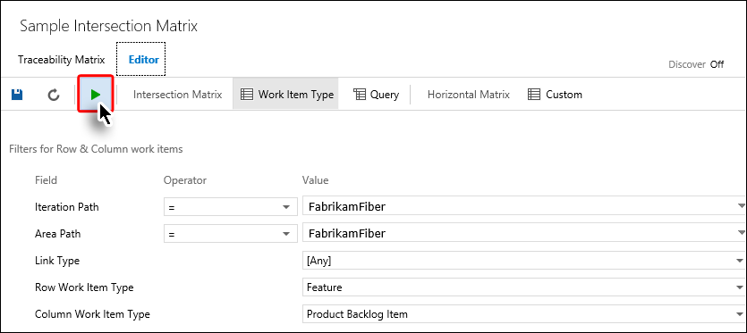

**Figure 15**

Running the query based on the configuration selections done in previous steps

* The Intersection Matrix is generated

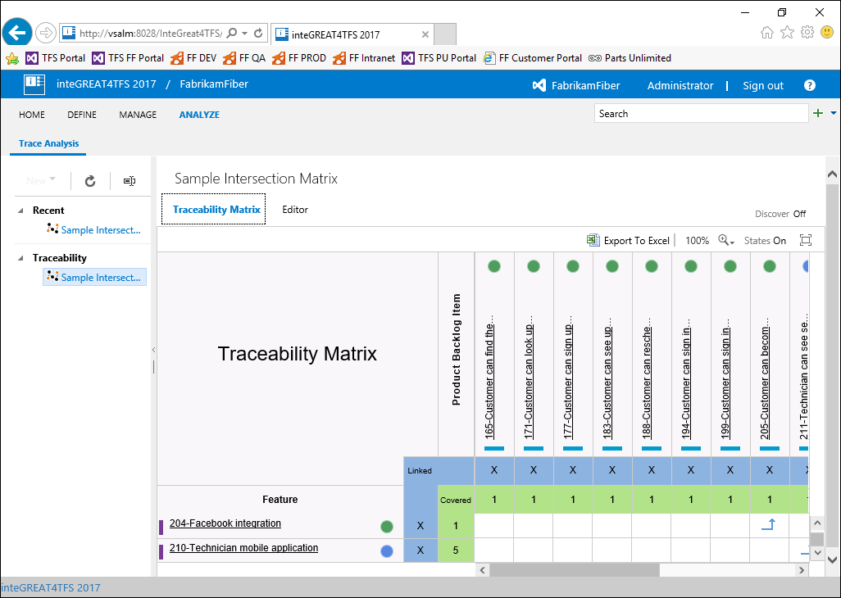

**Figure 16**

The Intersection Matrix just after its creation

1. To view the matrix in full screen mode, click the **Full Screen** Button at the top-right side of the matrix.

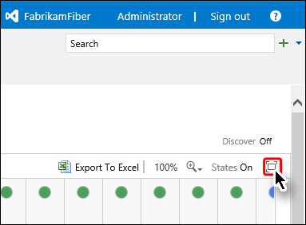

**Figure 17**

Invoking the Full Screen Mode

* The Matrix is displayed in Full Screen Mode. You can also adjust the Zoom Ratio to view more information simultaneously.

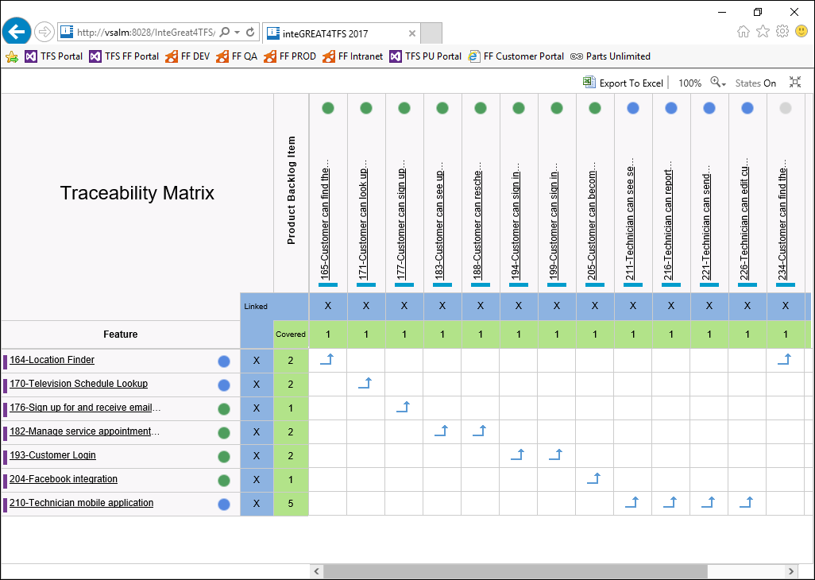

**Figure 18**

Intersection Matrix in Full Screen Mode

* To exit from the Full Screen Mode click the same button once again.

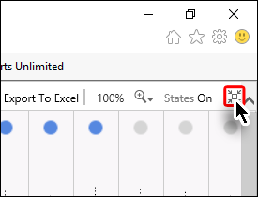

**Figure 19**

Invoking the Regular Mode

### Exercise 2.2: Adding/deleting relationships in Intersection Matrix

In this exercise you will learn how to add or remove relationships in the Intersection Matrix.

* The arrows in the intersection cell of the matrix denote that a relation exists between corresponding Work Items of the row and column.

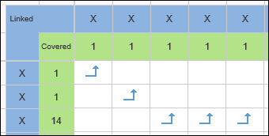

**Figure 20**

Arrows in the Intersection Matrix

* All types of relationships are grouped into three link types. The following table sums up the legends used.

**Icon Relationship Link Type**

 Network

 Dependent

 Tree

#### **Adding a relationship**

1. Invoke **Trace Analysis** module from Dashboard.
2. Create / open an Intersection Matrix.

1. Determine the intersection cell for creating a relationship between corresponding Work Items.

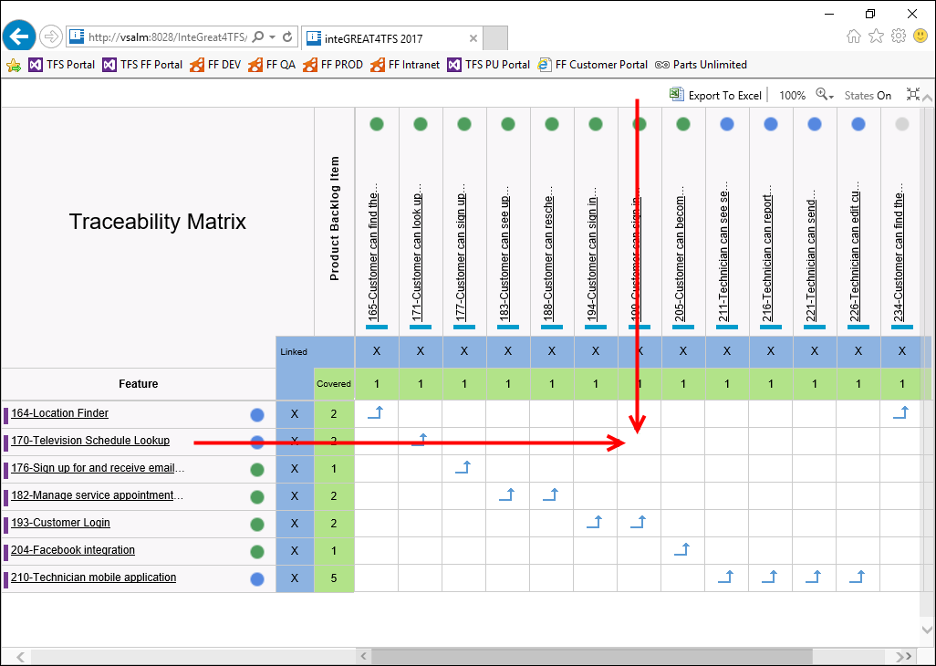

**Figure 21**

The target intersection cell to create a relationship

1. Place the mouse over the intersection cell.

* The cell would show a + sign.

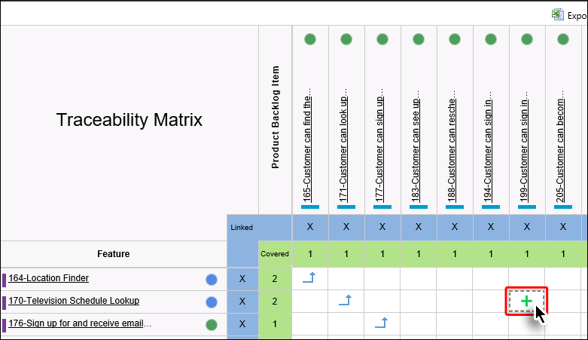

**Figure 22**

The + sign in the cell

1. Click the + sign.
2. Select the desired type of relationship.

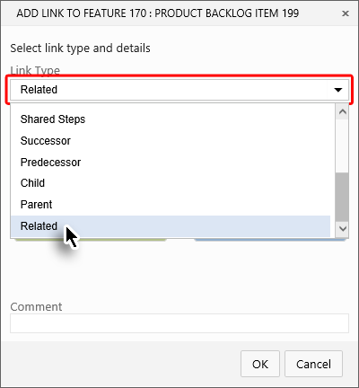

**Figure 23**

Selecting the desired relationship type

1. Click the **OK** Button.

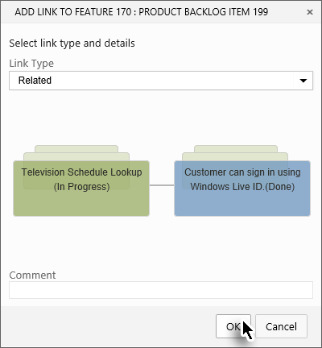

**Figure 24**

Completing the relationship creation process

* The relationship is created in the target cell of the Intersection Matrix.

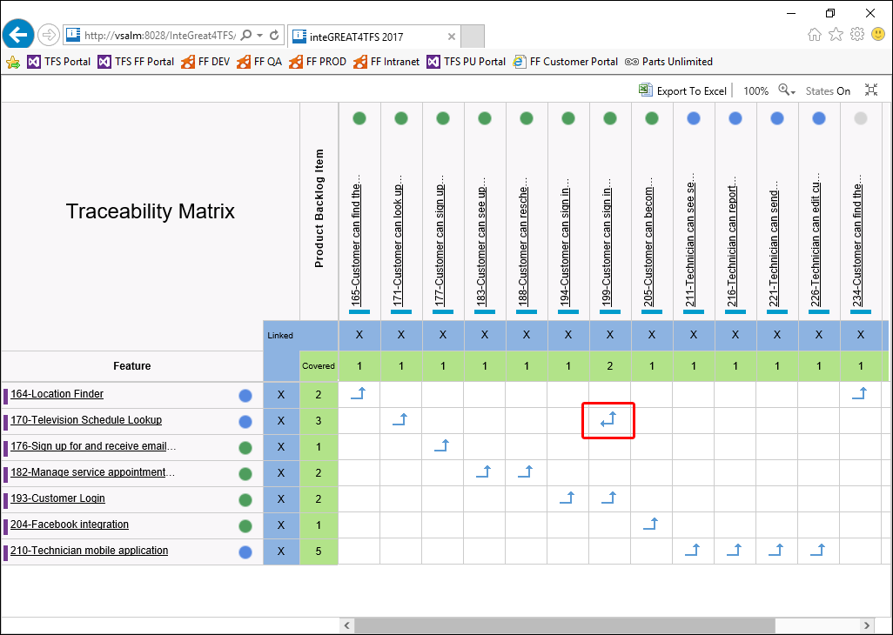

**Figure 25**

The newly created relationship as depicted in the Intersection cell of the matrix

* The relationship does not only show-up in the matrix. It can also be seen using Web Access or Visual Studio

#### **Deleting a relationship**

* Deleting the relationship is very similar to how we created the relationship

1. Determine the intersection cell for deleting relationship between corresponding Work Items.
2. Place the mouse over the intersection cell.

* The cell would show a - sign.

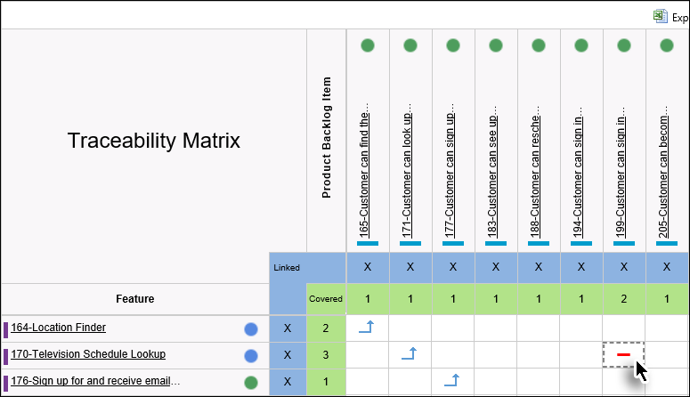

**Figure 26**

The - sign in the cell

1. Click the - sign.
2. Click the **OK** Button.

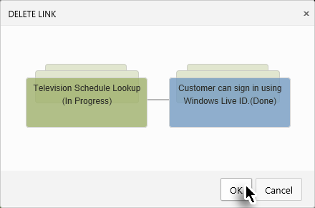

**Figure 27**

Completing the relationship deletion process

* The relationship is deleted.

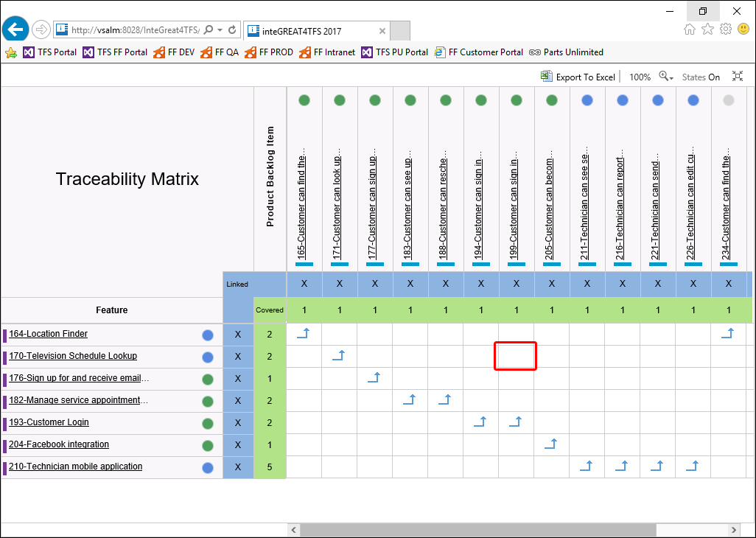

**Figure 28**

The intersection cell after deleting the relationship

* This brings us to the end of this exercise.

### Exercise 2.3: Editing Work Items

In this exercise you will learn how to edit Work Item properties (apart from link/relationship property that we have already discussed in previous exercise).

1. Invoke **Trace Analysis** module from Dashboard.
2. Create / open an Intersection Matrix.
3. Now place the mouse over the desired Work Item.

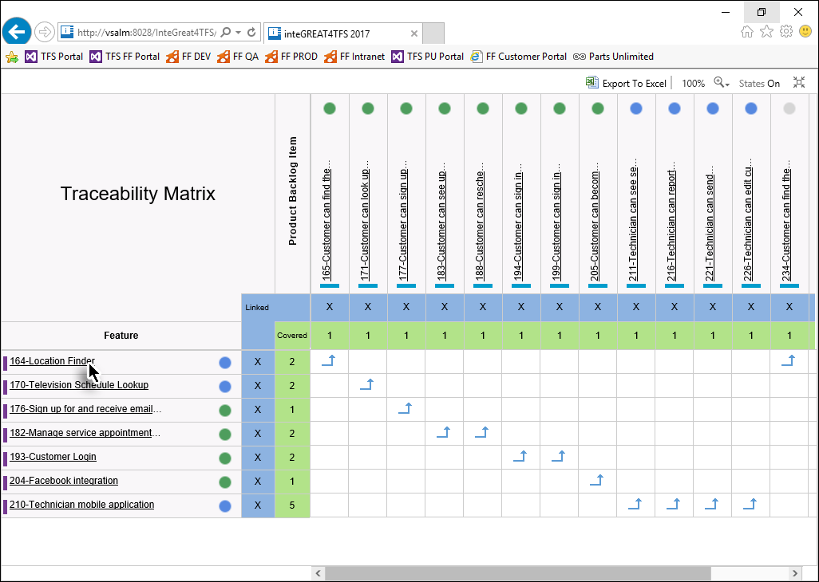

**Figure 29**

Invoking the mouse over event for the desired Work Item

1. Click the **Edit** icon in the popup window.

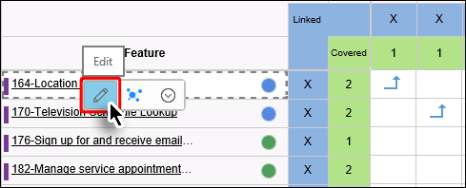

**Figure 30**

Clicking the Edit icon in the popup

1. Edit the desired properties of the Work Item and click the **Save** Button.

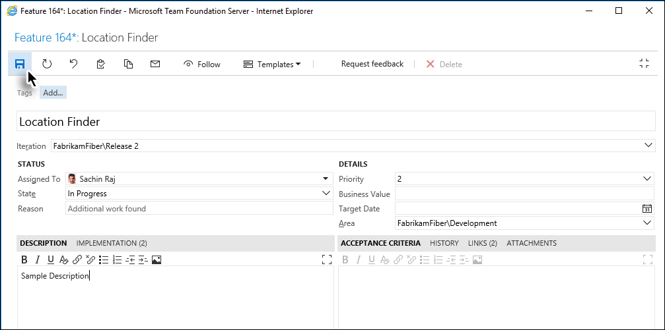

**Figure 31**

The Web Access window where the properties of the selected Work Item can be edited and saved.

1. Close the popup window.

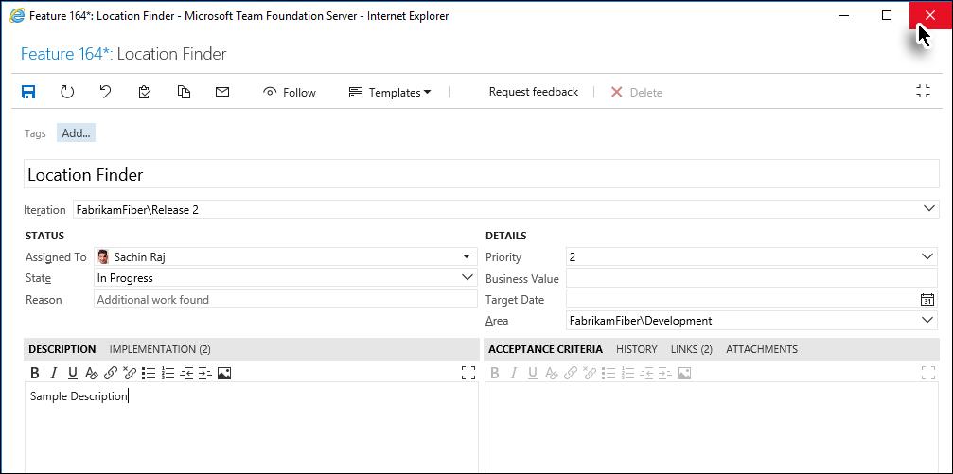

**Figure 32**

Completing the Work Item editing process

* The changes to the Work Item are save
* This brings us to the end of the exercise.

### Exercise 2.4: Creating a Horizontal Matrix

In this exercise you will learn how to create a Horizontal Matrix.

* The Horizontal Matrix shows what are the relations of a particular type of Work Item, and what are the relations of those relations, and so on (up-till level 3)

1. Invoke **Trace Analysis** module from Dashboard.
2. Click **New** and then **Traceability** options from the drop down.



Figure 33

Initiating the matrix creation process

1. Enter a suitable name for the Horizontal Matrix and click the **OK** Button.

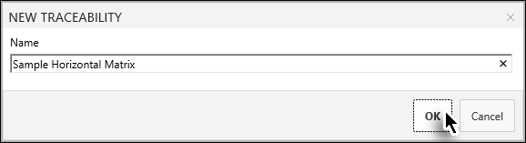

**Figure 34**

Naming the Horizontal Matrix

* Clicking the **Next** button takes us to the Editor page where we configure the settings to create the Horizontal (and also the Intersection) Matrix.

1. Click the **Custom** option.

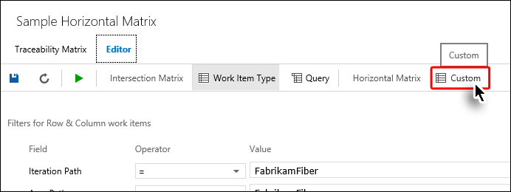

**Figure 35**

Clicking the Custom option to invoke the settings for creating Horizontal Matrix

1. Select the desired **Area** and **Iteration Path**.

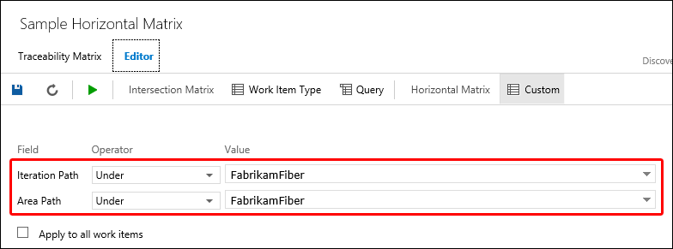

**Figure 36**

Configuring the Area and Iteration Paths

1. Select the relevant Work Item for Column 1.

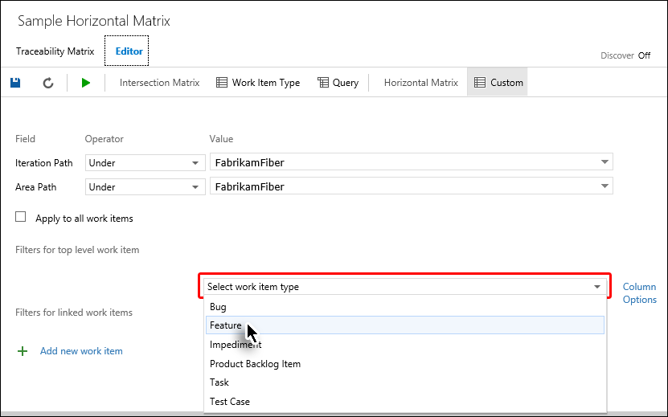

**Figure 37**

Selecting the Column 1 Work Item

* The Column 1 Work Item tells inteGREAT4TFS to show the list of all the Work Items of the selected type
* The Column 2 Work Item tells inteGREAT4TFS to show the list of selected type of Work Items that are linked with the Column 1 Work Items. Similar principle is followed for Colum 3 & 4 Work Items
* If a Column 1 Work Item has no relation with Column 2 Work Items but has a link with Column 3 or 4 Work Item(s) then it is also shown bypassing Column 2 Work Item.
* Selecting Column 1 Work Item is mandatory while all other columns are optional.

1. Similarly select the relevant Work Item(s) for additional Columns (if desired).

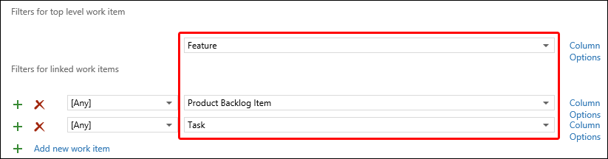

**Figure 38**

Selecting Column 2 and 3 Work Items

1. Click the **Run** Button in the Toolbar.

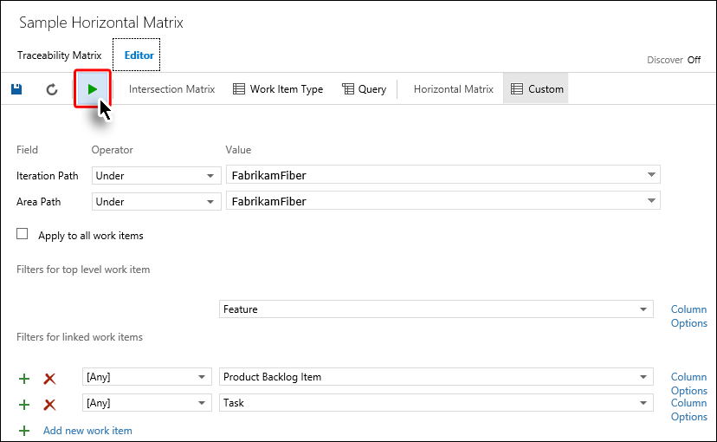

**Figure 39**

Completing the Horizontal Matrix creation process

* The Horizontal Matrix is generated and displayed

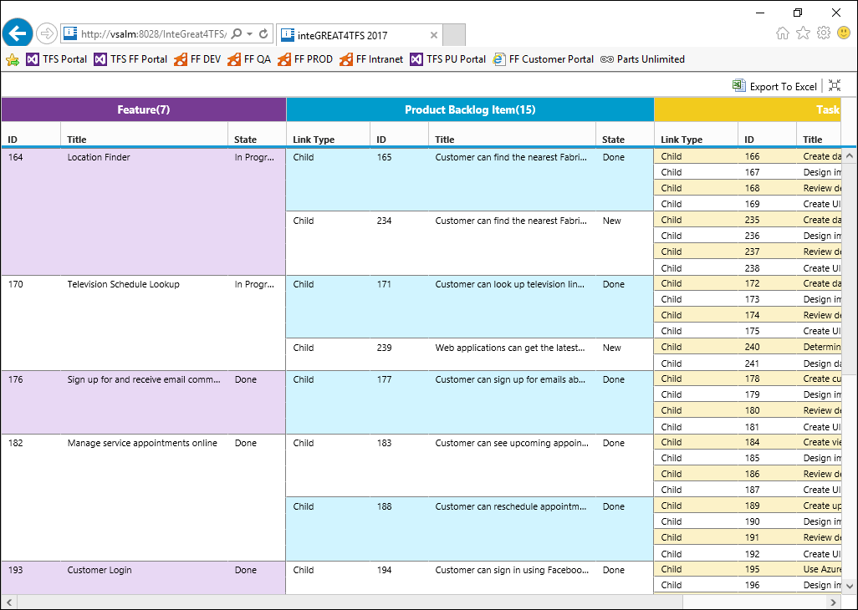

**Figure 40**

The Horizontal Matrix after generation

* This brings us to the end of this exercise.

### Exercise 2.5: Export to Excel

In this exercise you would learn how to export the desired type of matrix (Intersection or horizontal) to MS-Excel.

1. Invoke **Trace Analysis** module from Dashboard.
2. Create / open the desired type of matrix.
3. Click the **Export To Excel** option in the Mini Toolbar.

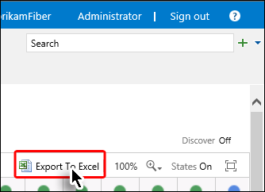

**Figure 41**

Clicking the Export to Excel option

* The Excel file is created.

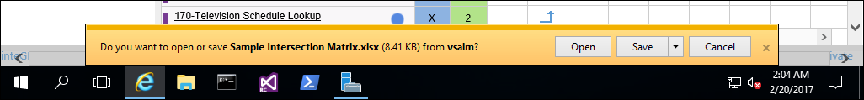

**Figure 42**

The notification of the recently created Excel File

* The file can now be opened in MS-Excel using **Open** or **Save** option as desired.

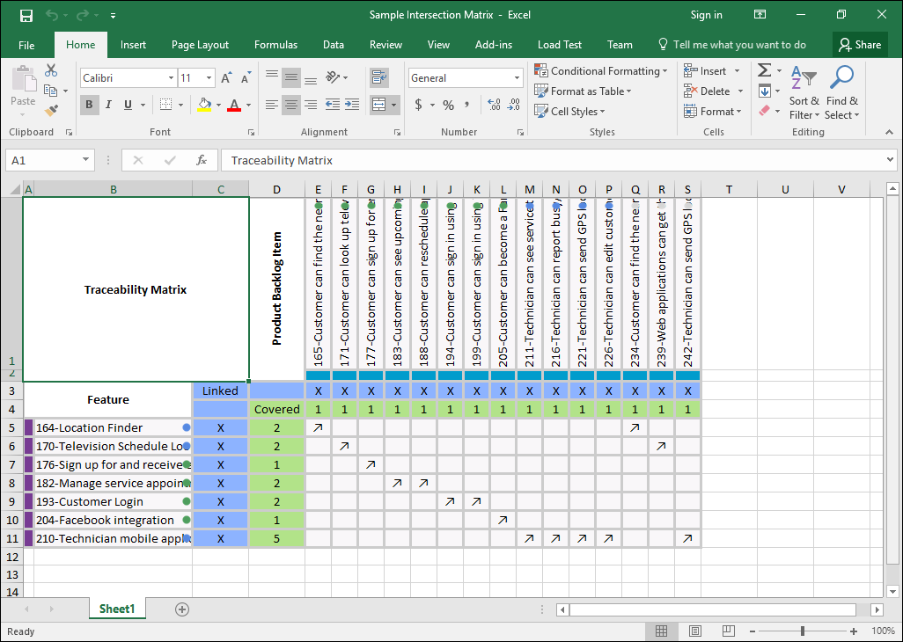

**Figure 43**

The exported file as it appears in MS-Excel

* This brings us to the end of this exercise.

## 3. Baseline Management with inteGREAT4TFS

### Exercise 3.1: Accessing inteGREAT4TFS and creating a baseline

In this exercise you will learn how to access inteGREAT4TFS and create a baseline using it.

* inteGREAT4TFS is an online application that complements SmartOffice4TFS in managing Team Projects. inteGREAT4TFS consists of many distinct modules such as: **Trace Analysis**, **SmartOffice Library**, **Simulation, Diagram, Use Case,** **Review** and **Baselining**. In this hands on lab, we would be using the **Baselining** module only.

1. Log in as **Brian Harry** (VSALM\Brian). All user passwords are **P2ssw0rd**.
2. Start Internet Explorer.
3. Access the following URL: **VSALM:8028**



* + 1. Figure 1

Accessing inteGREAT4TFS Tab

* The Login Page for inteGREAT4TFS is displayed in the browser.



**Figure 2**

Login Page for inteGREAT4TFS

* Following login details are to be used:
* TFS Server URL: [**http://VSALM:8080/tfs**](http://VSALM:8080/tfs)
* User ID: **Administrator**  
  Password: **P2ssw0rd**

1. Enter the login details and click the **Sign In** Button.



* + 1. Figure 3

Signing in using the recommended login details

* Home page is displayed.

1. Click the **Browse** link.



**Figure 4**

Browse link on the home page

1. Expand **FabrikamFibreCollection** node 🡪 select **Fabrikam Fiber** (Team Project) 🡪 click the **Navigate** Button.



* + 1. Figure 5

Selecting the Team Project

* Upon successful connection, the Dashboard of the selected Team Project (**Fabrikam Fiber**) is displayed.



**Figure 6**

Dashboard in inteGREAT4TFS

* **Dashboard** is the place where **the** user gets useful information about the team project. It also leads the users to the desired module in inteGREAT4TFS. Users can select their desired module in a number of ways. Since we would be using the **Baselining** module in this exercise, we would select it.

1. Select the **Baselining** link from the highlighted links shown in the following image.

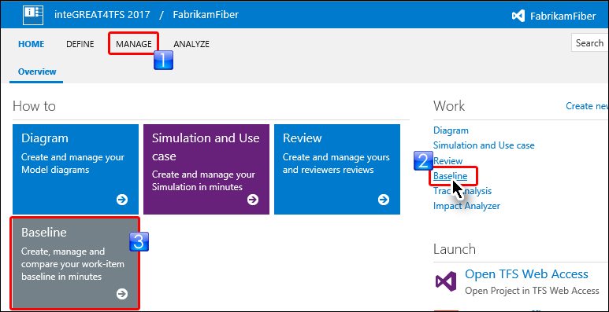

* + 1. Figure 7

Selecting the Baselining module

* In case **Manage** hub is used to invoke the module, user has to additionally select the Baseline option afterwards.

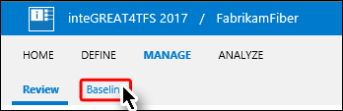

**Figure 8**

Invoking Baseline module through **Manage** hub

* The landing page of Baselining module is displayed. Originally it would be empty since we have not created any baseline as of yet.

1. Click **New** and then **Baseline** options from the drop down.

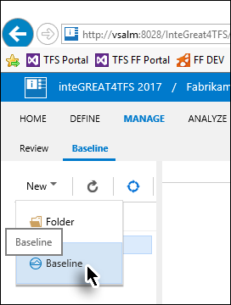

Figure 9

Invoking the baseline creation option

1. Enter a suitable name for the baseline; provide a description and click the **Next** Button.

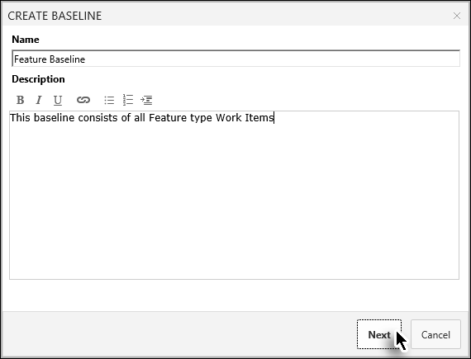

**Figure 10**

Entering the required information for the baseline

* Clicking the **Next** button takes us to the query window where we have to search for the Work Items that we want to include in the baseline. We can search based on saved queries, IDs, full or part of the name.

1. Select the desired query and click the **Find** Button.

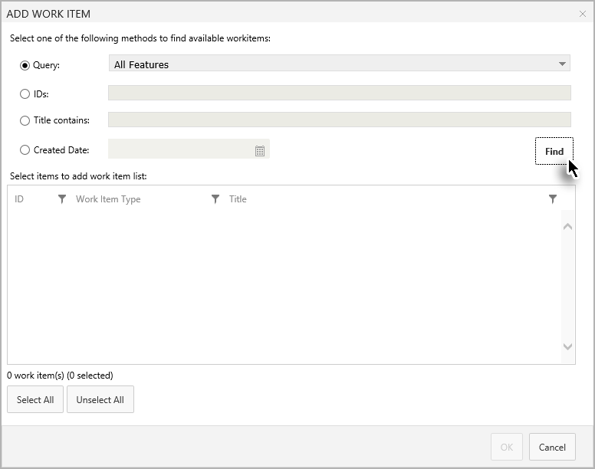

**Figure 11**

Finding the required Work Items

1. Select the desired Work Items from the query result and click the Add Work Items Button.

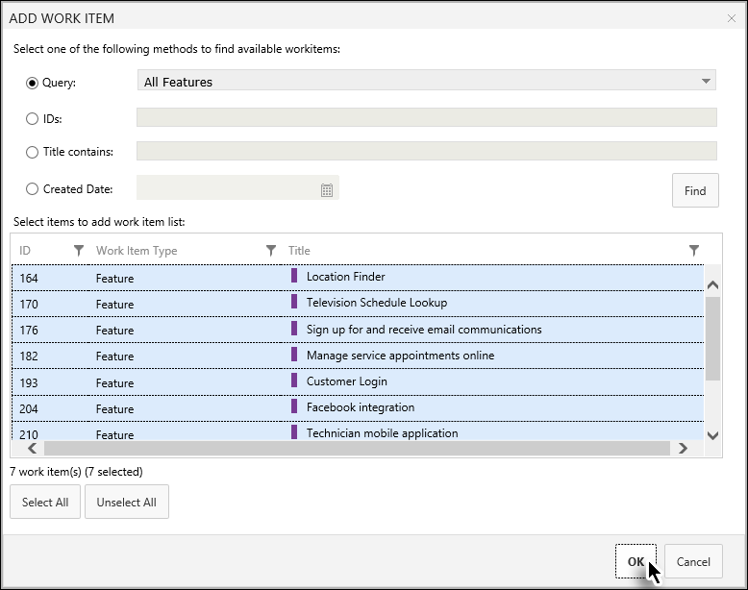

* + 1. Figure 12

Adding the desired Work Items in the baseline

* The Work Items window is closed and the added Work Items are listed in a new page. At this moment we have created a list of Work Items that are ready to be included in our baseline. However the baseline itself has not yet been created. This extra step helps users to include additional Work Items, remove unwanted ones, or edit them before finalizing the baseline.

1. Click the Save Button.

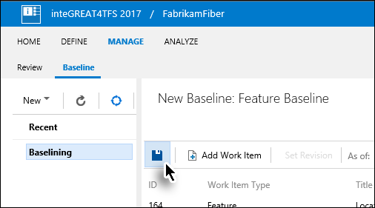

* + 1. Figure 13

Completing the baseline creation process

* The baseline is created

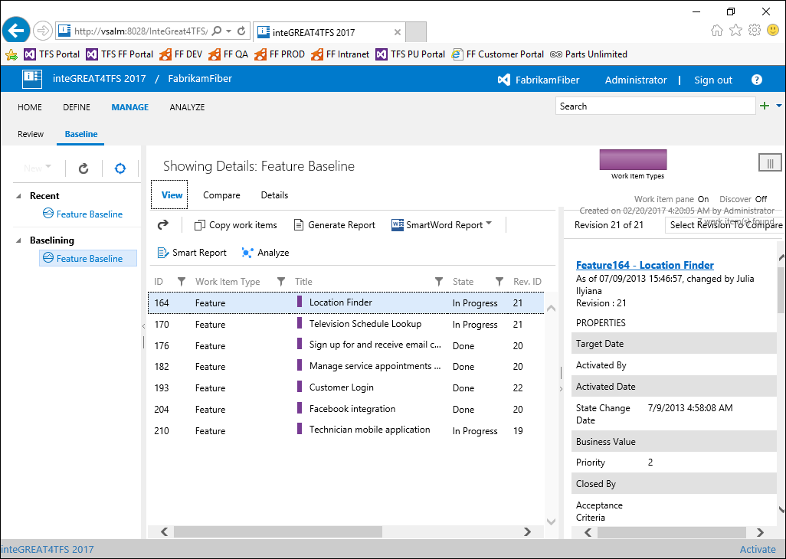

**Figure 14**

* Baseline as it appears just after creation.
* This brings us to the end of this exercise.

### Exercise 3.2: Generating Baseline Report

In this exercise you will learn how to generate a Baseline Report.

* A Baseline Report is created for a particular baseline. It contains details about the Work Item it contains.

1. Invoke the **Baselining** module from Dashboard.
2. Click the desired baseline in the Baseline Explorer Panel under Project Baselines.

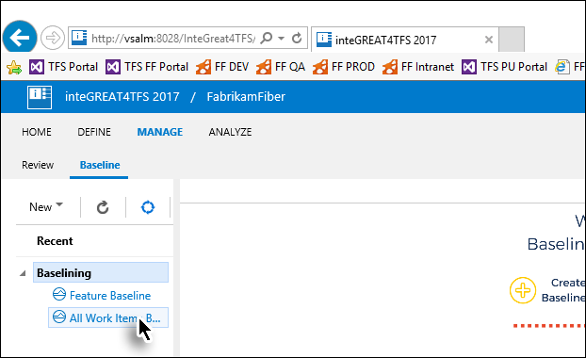

**Figure 15**

Selecting desired baseline to open

1. Click the **Generate Report** option in the toolbar.

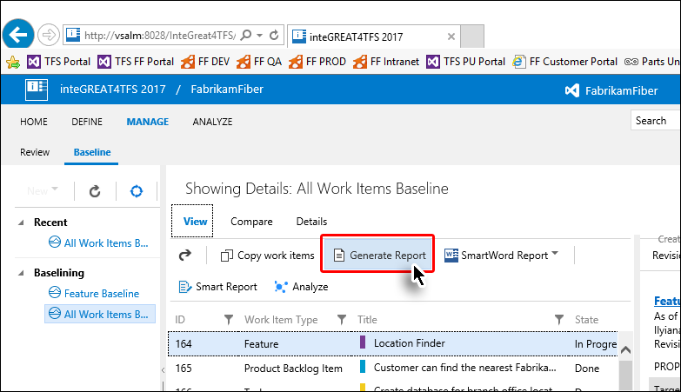

**Figure 16**

Clicking the Generate Report option

* The report is generated and can be opened in Microsoft Word.

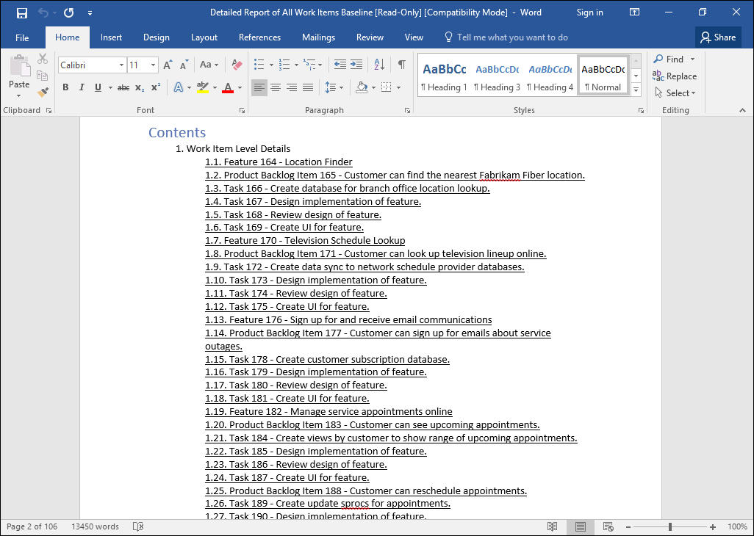

**Figure 17**

The Baseline Report opened in MS-Word

* This brings us to the end of this exercise.

### Exercise 3.3: Comparing Baselines

In this exercise you will learn how to compare two baselines and create a difference report.

1. Invoke the **Baselining** module from Dashboard.
2. Open the desired baseline using the Baseline Explorer Panel.
3. Now click the **Compare** Tab (below the baseline’s name in the Main Panel)

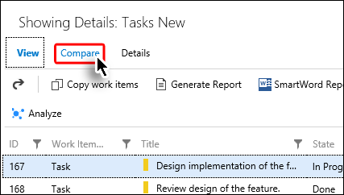

**Figure 18**

Invoking the Compare Tab

1. Click on the downward arrow in the Main Toolbar.

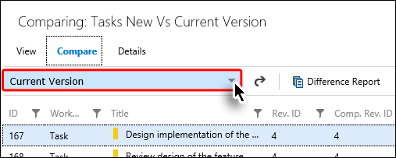

**Figure 19**

Invoking the Comparison drop down

1. Select the desired baseline to compare with the current baseline

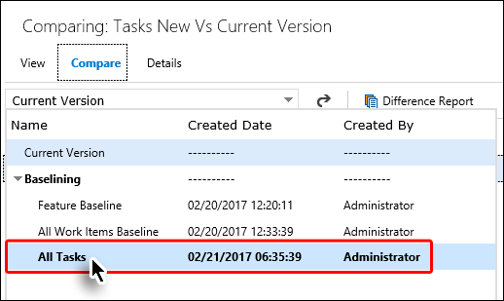

**Figure 20**

Selecting the baseline for comparison

* The comparison between two baselines is shown in the Grid. The Work Items that were updated are mentioned as Changed in the “**Comp. Status”** column (highlighted in the image).

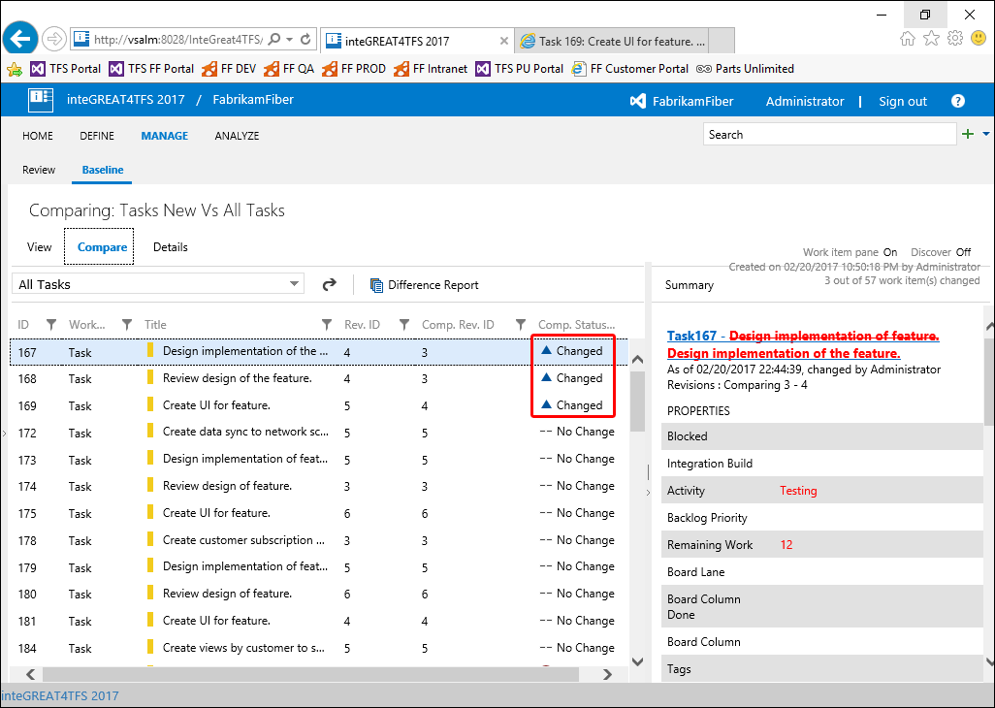

**Figure 21**

Baseline comparison

* The actual updates in the selected Work Items are shown in the **Work Item Details Panel** (at the right hand side of the window). If the difference is not evident, then click the **Summary** Button at the top right of the Work Items Details Pane. This would show only the differential values in the pane.

1. To switch to the **Summary Mode** (for easy viewing of updates), click the **Summary** option in the **Work Item Details Panel**.

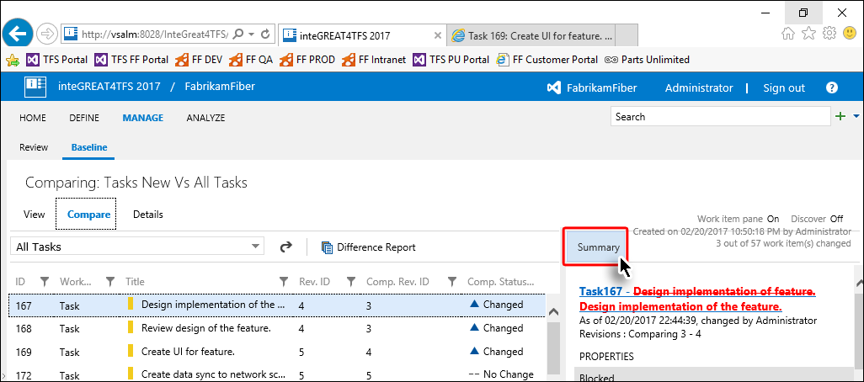

**Figure 22**

Switching to Summary Mode

* The **Work Item Details Panel** now shows only the values that were updated.

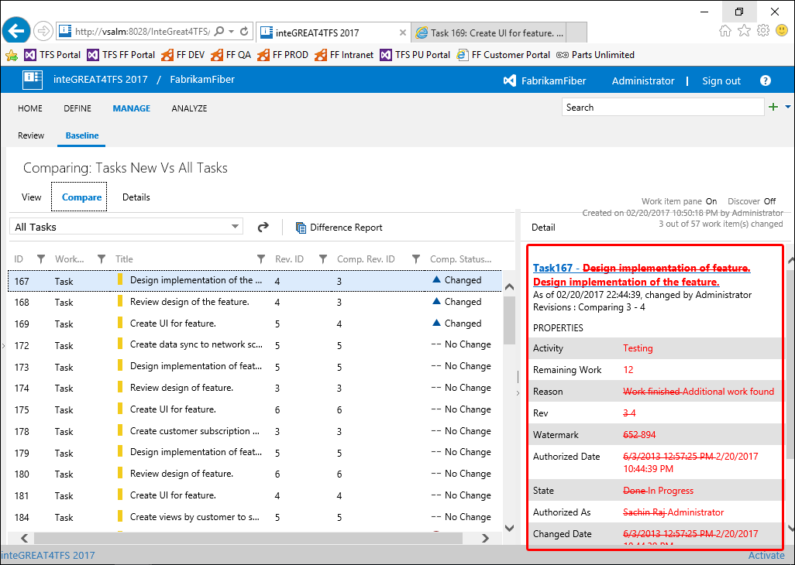

**Figure 23**

The **Work Item Details Panel** in Summary Mode

1. Click the **Difference Report** option in the Main Toolbar.

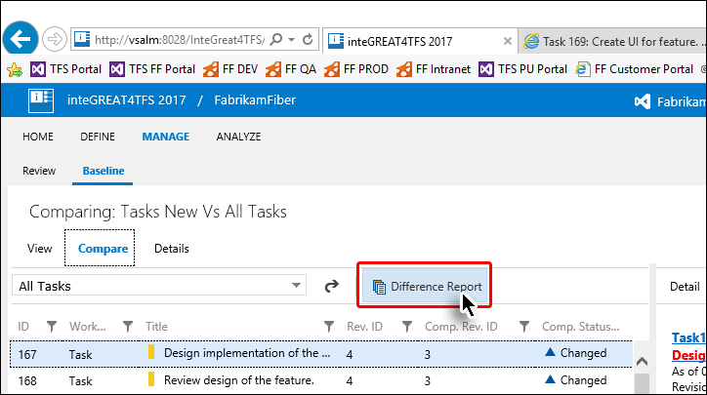

**Figure 24**

Creating the Difference Report (Step1)

1. Enter required information and click the **Generate** Button.

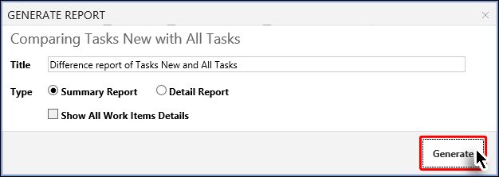

**Figure 25**

Creating the Difference Report (Step2)

* The Difference Report is created in MS-Word format

1. Save or Open the file to complete the process.

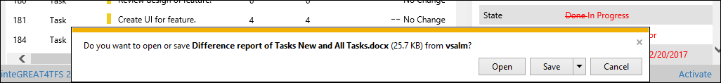

**Figure 26**

Message shown after the creation of the Difference Report

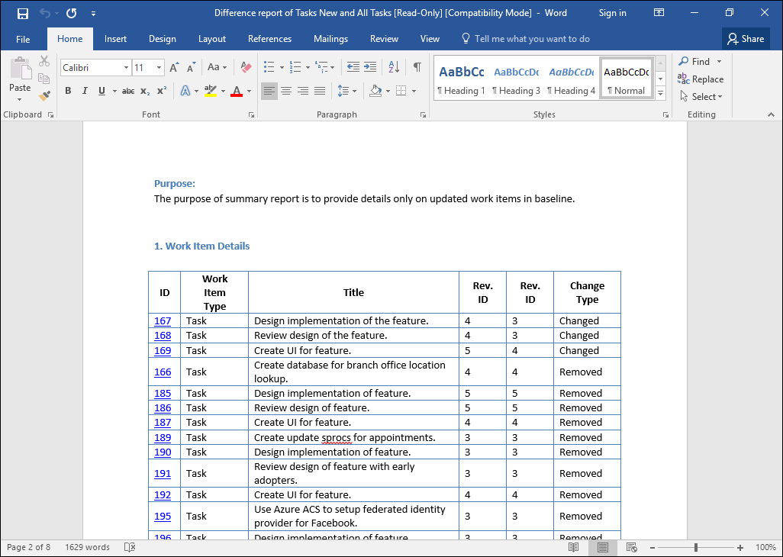

**Figure 27**

The Difference Report opened in Microsoft Word

### Exercise 3.4: Copying baselines

In this exercise you will learn how to copy a baseline (or its Work Items) to create a new baseline. The copied baseline can be pasted into the same team project or into another project. In both cases the process is same, with only change in the target team project option.

1. Open the desired baseline.
2. Click the **Copy Work Items** option in the Main Toolbar.

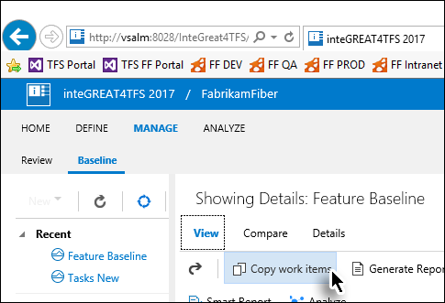

**Figure 28**

Initiating the Copy baseline process

* The Copy Work Item Window appears. Its options are divided under three sections as marked in the image.

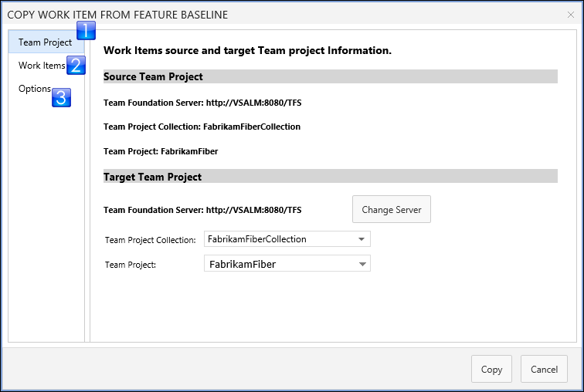

**Figure 29**

The Copy Work Item window

* The Team Project option (in the Target Team Project section) tells where the baseline will be copied. Into the same team project or into another one, for example a re-use library project?

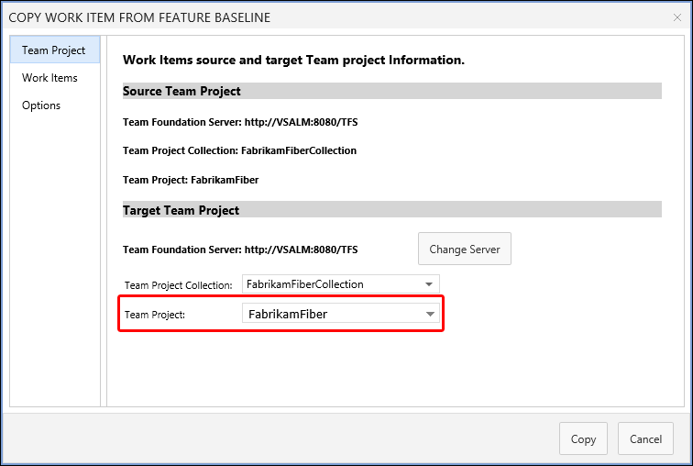

**Figure 30**

The Target Team Project option

1. Set the options in the **Team Project** section and then click the **Work Items** Tab in the window.

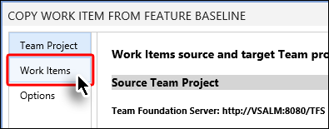

**Figure 31**

Moving towards “**Work Items**” Tab

* Here All Work Items are shown that are in the selected baseline. Users can select all Work Items (using **Select All** Button) or individually select the desired Work Items (using **Ctrl + click)**.

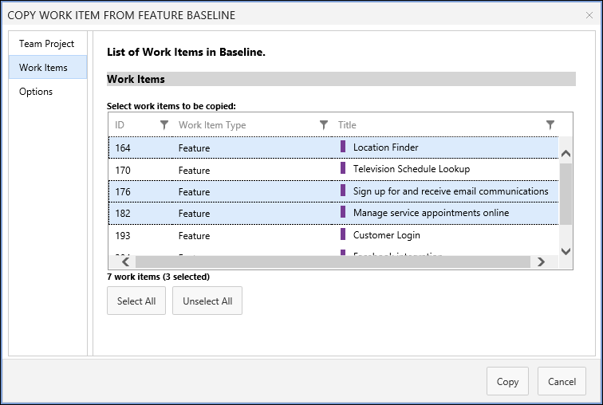

**Figure 32**

Work Item options

1. Select the desired Work Items and then click the **Options** Tab.

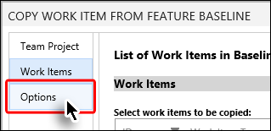

**Figure 33**

Moving towards different options in the “**Options**” Tab

* If we enable the **Create Baseline of copy work item(s)** checkbox (marked in the image below) then the baseline is copied as well, otherwise only the selected work items are copied.

1. Set desired options and click the **Copy** Button.

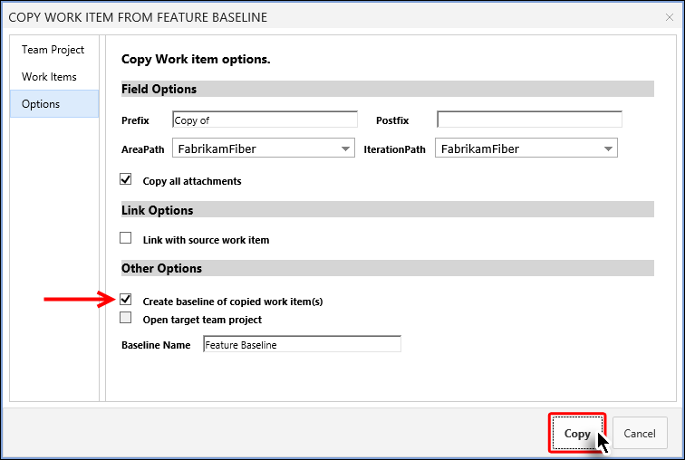

**Figure 34**

Completing the baseline copying process

* A copy of the baseline is created and a message is displayed.

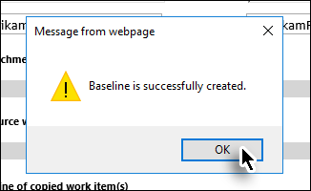

**Figure 35**

Baseline creation message

* The newly created baseline is now accessible through the Baseline Explorer Panel.

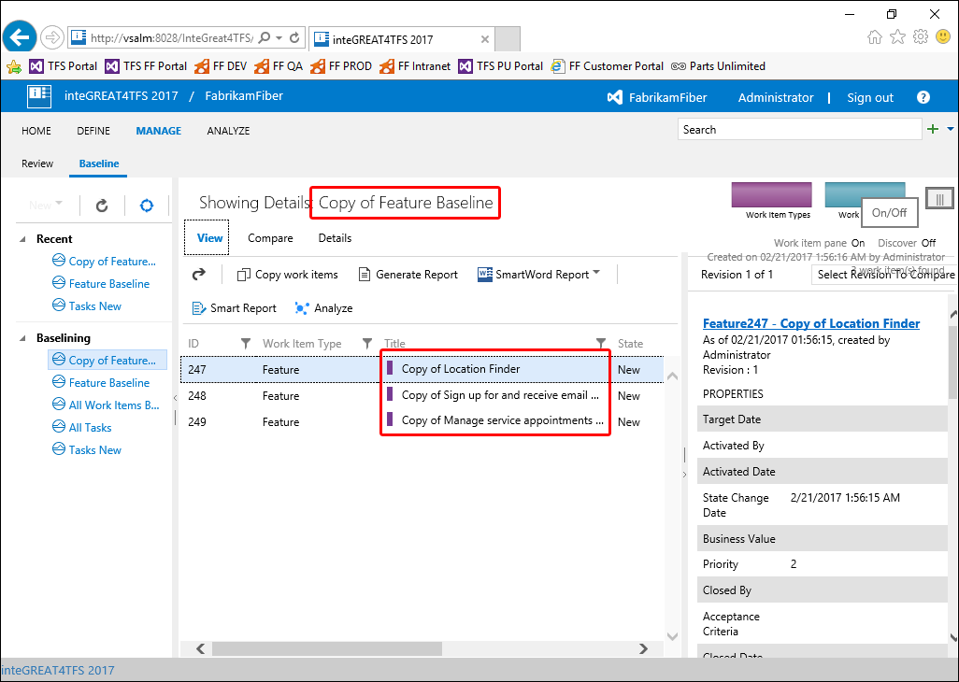

**Figure 36**

Newly created baseline

* This brings us to the end of this exercise.

## 4. Review Management with inteGREAT4TFS

### Exercise 4.1: Creating a Review Request

In this exercise you will learn about how to create a Review Request using the Review Management module of inteGREAT4TFS.

* inteGREAT4TFS is an online application that complements SmartOffice4TFS in managing Team Projects. inteGREAT4TFS consists of many distinct modules such as: **Trace Analysis**, **SmartOffice Library**, **Simulation, Diagram, Use Case,** **Review** and **Baselining**. In this HOL, we will be using the **Review** module only.

1. Using the method described in baseline/traceability HOL, log in as **Administrator.**
2. Navigate to the inteGREAT4TFS Dashboard.



**Figure 1**

Dashboard in inteGREAT4TFS

* **Dashboard** is the place wheretheuser gets useful information about the team project. It also leads the users to the desired module in inteGREAT4TFS. Users can select their desired module in a number of ways. Since we will be using the **Review** module in this exercise, we will select the Review link that leads to our desired module.

1. Select the **Review Management** link from the highlighted links shown in the following image.

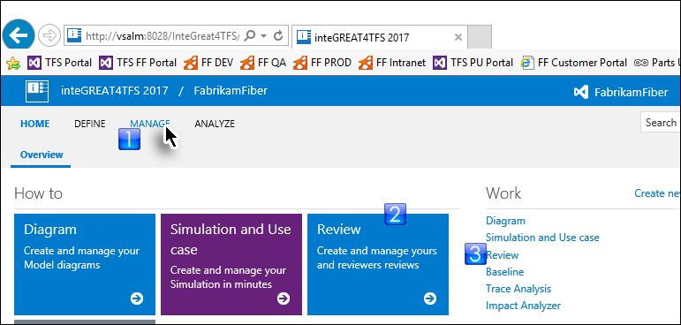

* + 1. Figure 2

Selecting the Review Management link

* The landing page of the Review Management is displayed. The landing page would be empty since neither we have generated any Review Requests nor any requests have been assigned to us as of yet.

1. Click **New** and then **Review Request** option from the drop down.

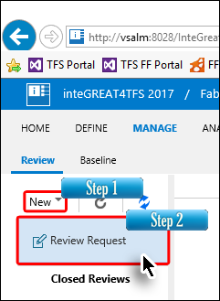

Figure 3

Invoking the Review Request option

* The Review Request Popup is displayed. This popup is used to configure all the settings for the Review Requests

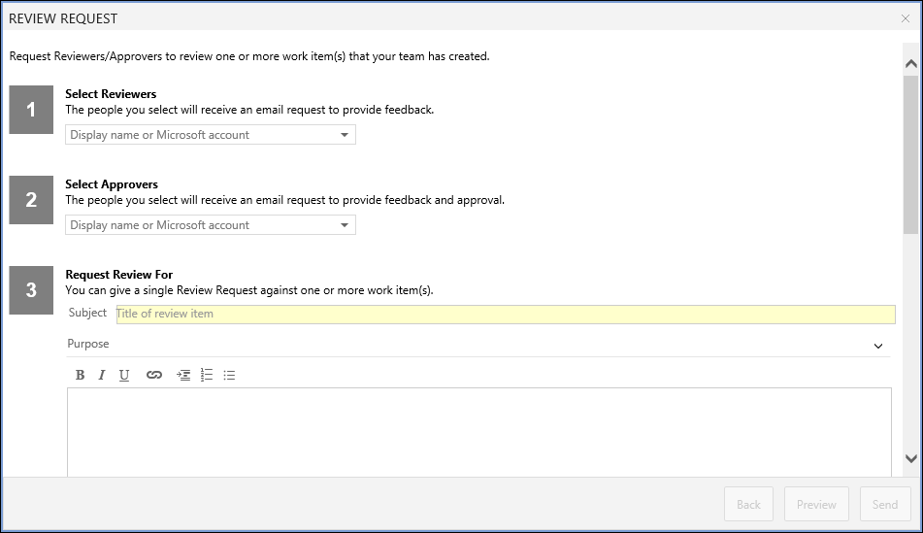

**Figure 4**

The Review Request popup window

1. Select the Reviewers from the drop-down list.

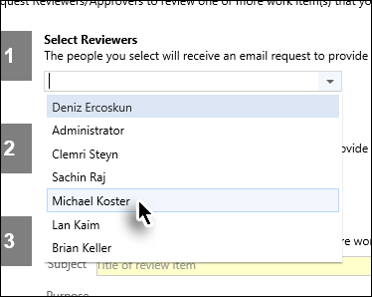

**Figure 5**

Selecting the Reviewers

* You can select more than one reviewer

1. Similarly, select the desired Approvers.

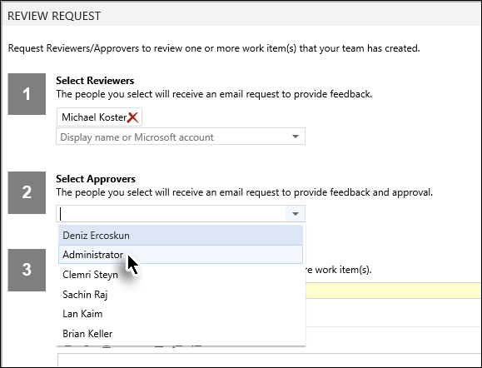

**Figure 6**

Selecting the Approvers

* **Reviewers** only provide comments while **Approvers** can also approve/reject. A particular person can be either selected as a reviewer or an approver.

1. Enter appropriate subject for the review request.

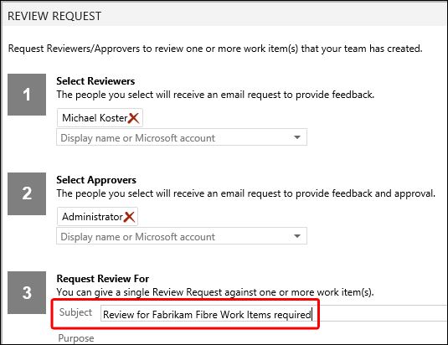

**Figure 7**

Entering subject for the Review Request

* The subject of the Review Request becomes the subject of the email that is sent by inteGREAT4TFS to the selected Approvers/Reviewers

1. Scroll down to get to the other steps in the window.
2. Provide a purpose for the review (if desired). Alternatively collapse the section by clicking on the down arrow at far right.

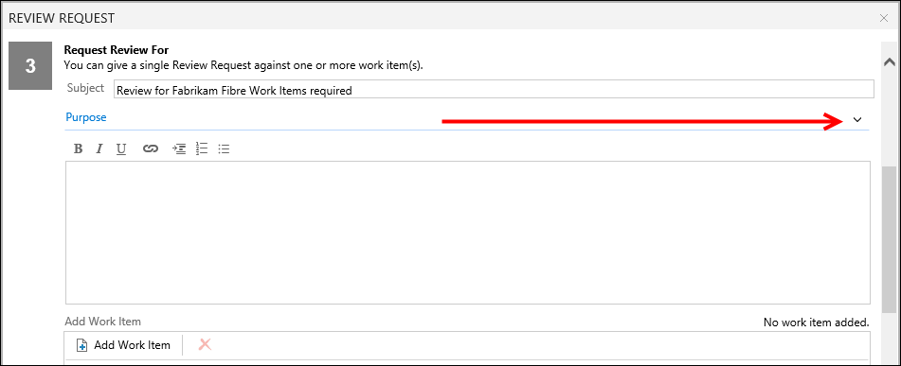

* + 1. Figure 8

The Purpose section in the popup window

1. Click the Add Work Items button.

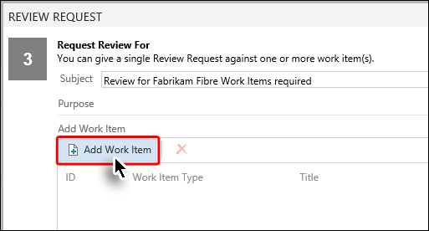

* + 1. Figure 9

Clicking the Add Work Item Button

1. Run the relevant query.

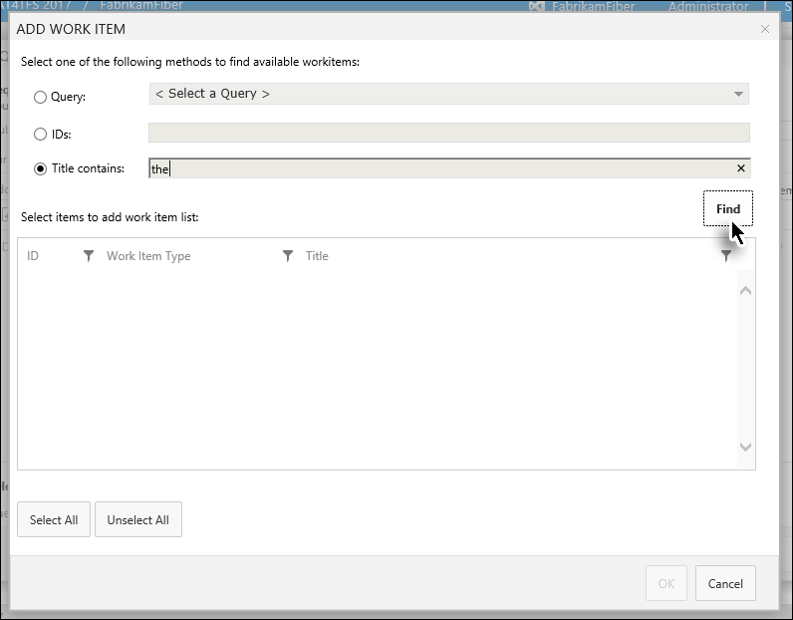

**Figure 10**

Running the query to add desired Work Items

* A list of Work Item appears depending upon the query we ran. We can now select the desired ones from the list.

1. Select the desired Work Items (for which the review is desired) and click the **Add Work Item** button.

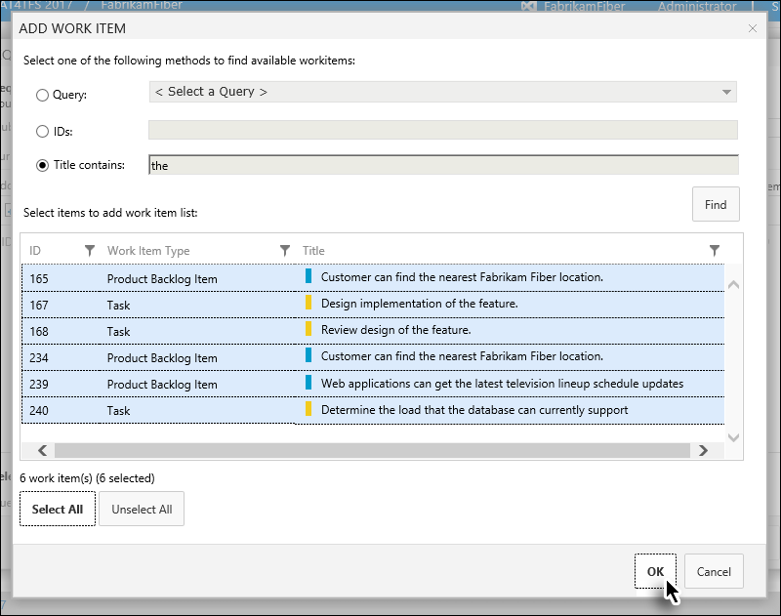

**Figure 11**

Selecting the desired Work Items

1. Set the Due Date.

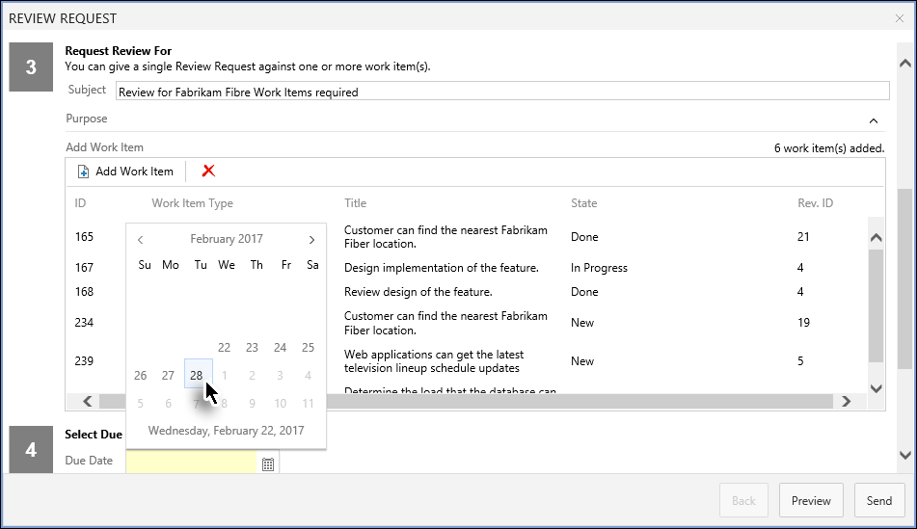

**Figure 12**

Setting the Due Date

1. To preview the request, click the **Preview** button.

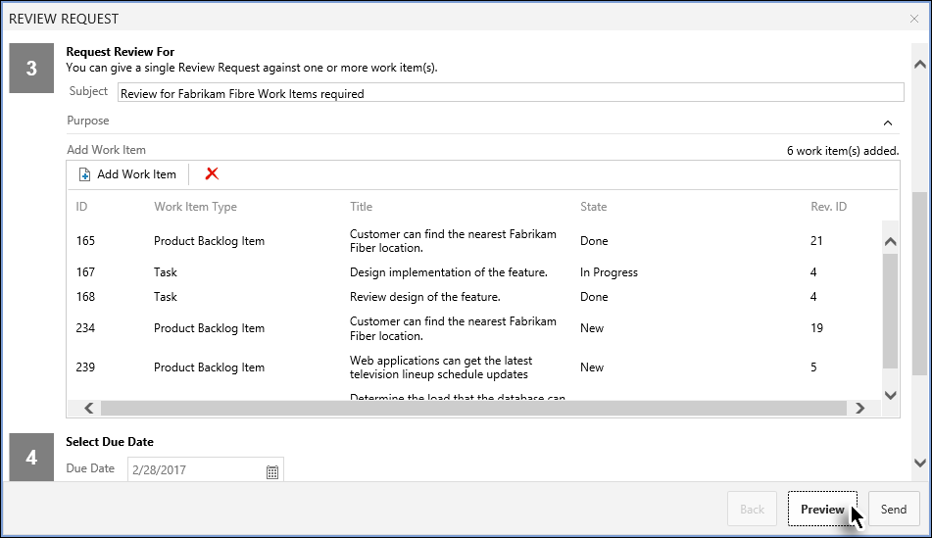

**Figure 13**

Invoking the Preview

* The Preview is displayed. In preview, only the text box area is editable. All other information such as recipients, Due Date etc. are shown in read-only format. If these need to be edited then user has to go back and alter the relevant options.

1. Make formatting updates (if desired) and click the Send button.

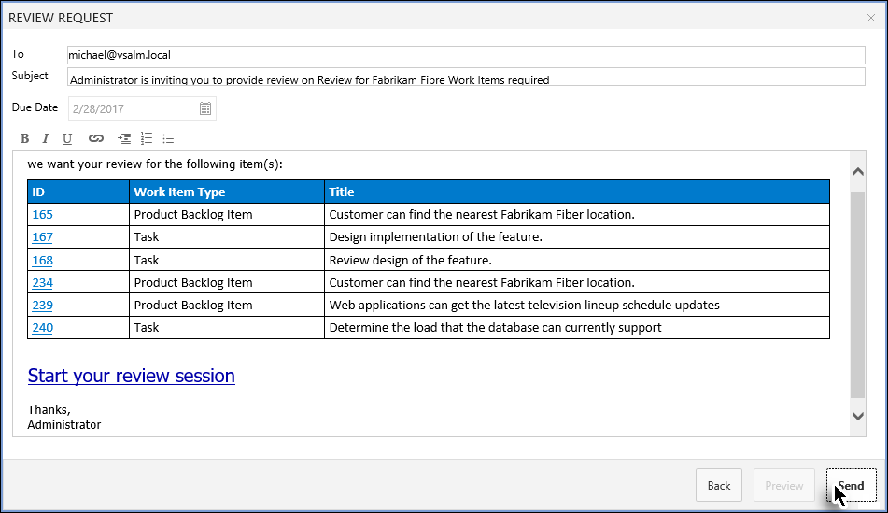

**Figure 14**

Completing the Review Request

* The Review Request is created and becomes visible at the module's landing page.

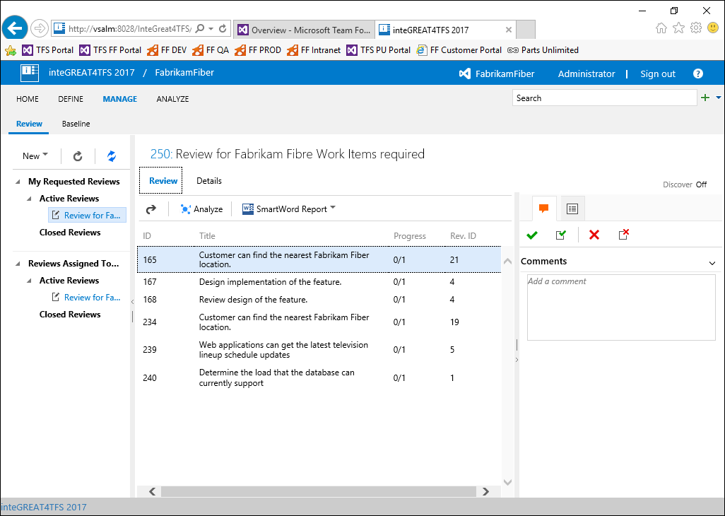

**Figure 15**

The Review Request as it appears just after creation

* This brings us to the end of this exercise.

### Exercise 4.2: Responding to the Review Requests

In this exercise you will learn about how to respond to a Review Request using the Review Management module of inteGREAT4TFS.

* The Review Requests assigned to a user are arranged under **Assigned to Me** heading in the Folder Explorer.

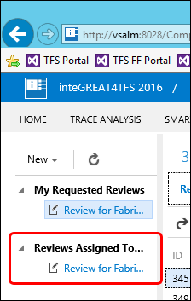

**Figure 16**

The Reviews Assigned to Me section in the Folder Explorer

* The process to respond to the review requests is slightly different for Reviewers and for Approvers. The following steps describe the process for Approvers. The Reviewers can only give their comments. The Accept/Reject options don’t appear in the UI for reviewers.

1. Click the relevant Review Request under the **Reviewed** **Assigned To Me** heading in the Folder Explorer.

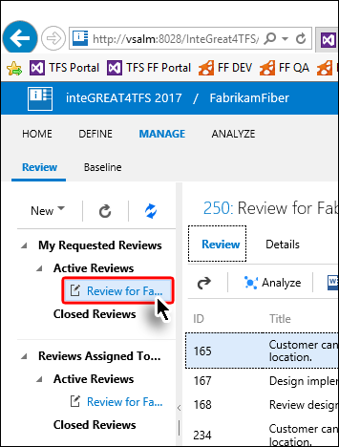

**Figure 17**

Selecting the Review Request for response

1. Select the Work Item for which the review is to be given.

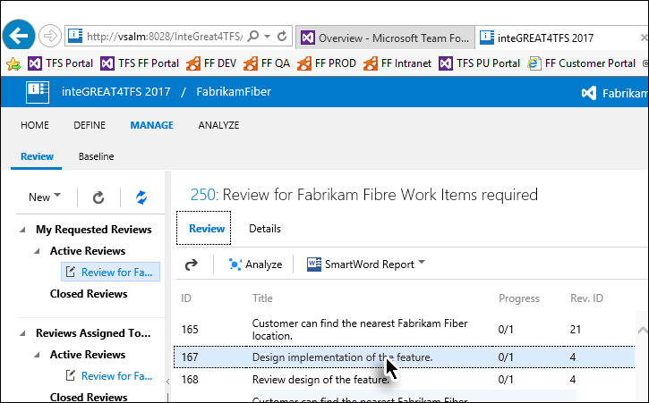

**Figure 18**

Selecting the Work Item

1. Provide a comment (if desired)

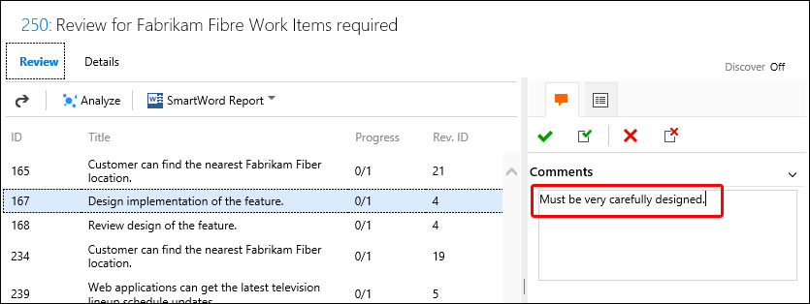

**Figure 19**

Providing comment against the selected Work Item

1. Click **Accept** or **Reject** Button.

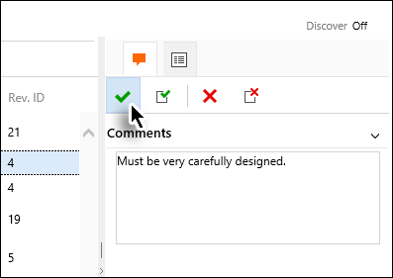

**Figure 20**

Clicking the Accept Button

* The response for the selected Work Item is completed.

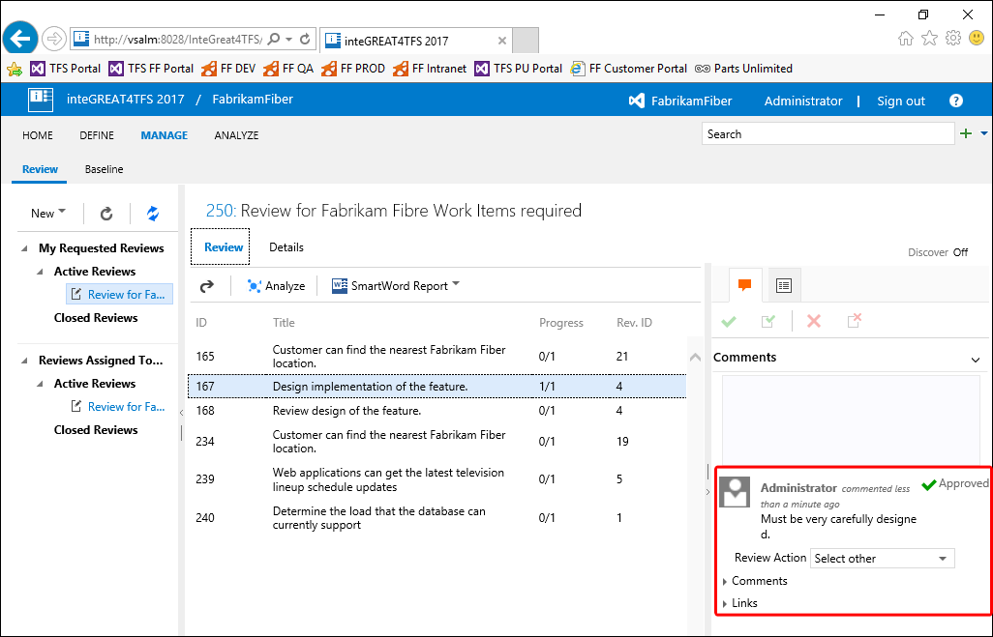

**Figure 21**

The response of the selected Work Item as it appears after process completion

1. Repeat the process with all other Work Items of the Review Request.

* Giving comment is not mandatory for approvers; however, it is mandatory for stakeholders.

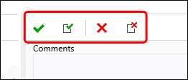

**Figure 22**

The Accept/Reject options available only to Approvers

* If **Accept All** or **Reject All** option is selected instead of simple Accept/Reject then the response is finalized for all Work Items of the Review Request and the user does not have to repeat the whole process for each Work Item as mentioned in last step.